UNITED STATES

SECURITIES AND EXCHANGE COMMISSION
WASHINGTON, D.C. 20549

FORM 10-Q

(Mark One)

☒ QUARTERLY REPORT PURSUANT TO SECTION 13 OR 15(d) OF THE SECURITIES EXCHANGE ACT OF 1934

For the quarterly period ended June 30, 2024

or

☐ TRANSITION REPORT PURSUANT TO SECTION 13 OR 15(d) OF THE SECURITIES EXCHANGE ACT OF 1934

For the transition period from _______ to _______

Commission File Number: 001-41184

ZYVERSA THERAPEUTICS, INC.

(Exact name of registrant as specified in its charter)

 | Delaware |  |  |  |  |  | 86-2685744
 | (State or other jurisdiction |  |  |  |  |  | (I.R.S. Employer
 | of incorporation or organization) |  |  |  |  |  | Identification No.)
 | 2200 N. Commerce Parkway, Suite 208
 | Weston, FL 33326 |  |  |  |  |  | 33326
 | (Address of registrant’s principal executive offices) |  |  |  |  |  | (Zip Code)
 |  | (754) 231-1688
 |  | (Registrant’s telephone number, including area code)
Securities registered pursuant to Section 12(b) of the Act:
 | Title of each class |  |  | Trading Symbol |  |  | Name of each exchange on which registered
 | Common Stock, $0.0001 par value per share |  |  | ZVSA |  |  | The Nasdaq Capital Market

Securities registered pursuant to Section 12(g) of the Act: None

Indicate by check mark whether the registrant: (1) has filed all reports required to be filed by Section 13 or 15(d) of the Securities Exchange Act of 1934 during the preceding 12 months (or for such

shorter period that the registrant was required to file such reports), and (2) has been subject to such filing requirements for the past 90 days. Yes: ☒ No: ☐

Indicate by check mark whether the registrant has submitted electronically every Interactive Data File required to be submitted pursuant to Rule 405 of Regulation S-T (§232.405 of this chapter) during the preceding 12 months (or for such shorter period that the registrant was required to submit such files). Yes: ☒ No: ☐

Indicate by check mark whether the registrant is a large accelerated filer, an accelerated filer, a non-accelerated filer, a smaller reporting company, or an emerging growth company. See the definitions of “large accelerated filer,” “accelerated filer,” “smaller reporting company,” and “emerging growth company” in Rule 12b-2 of the Exchange Act.

Large accelerated filer | ☐ | Accelerated filer | ☐
Non-accelerated filer | ☒ | Smaller reporting company | ☒
 |  | Emerging growth company | ☒

If an emerging growth company, indicate by check mark if the registrant has elected not to use the extended transition period for complying with any new or revised financial accounting standards provided pursuant to Section 13(a) of the Exchange Act. ☐

Indicate by check mark if the registrant is a shell company (as defined in Rule 12b-2 of the Exchange Act). Yes: ☐ No: ☒

As of August 8, 2024, the number of shares outstanding of the registrant’s common stock, $0.0001 par value per share, was 1,029,196.

Except as otherwise indicated, all share and per share information in this Report gives effect to the reverse stock split of the registrant’s outstanding common stock at a ratio of one-for-ten shares, which was effected as of 4:01 p.m. Eastern Time on April 25, 2024.

ZYVERSA THERAPEUTICS, INC.

INDEX TO CONDENSED CONSOLIDATED FINANCIAL STATEMENTS

 | PART I FINANCIAL INFORMATION |  |  |  |  |  |  |  |  |  |  |  |  |  |  |  |  |  |  |  | 1
 |  | Item 1. Financial Statements |  |  |  |  |  |  |  |  |  |  |  |  |  |  |  |  |  |  | 1
 |  |  | Condensed Consolidated Balance Sheets as of June 30, 2024 (unaudited) and December 31, 2023 |  |  |  |  |  |  |  |  |  |  |  |  |  |  |  |  |  | 1
 |  |  | Unaudited Condensed Consolidated Statements of Operations for the Three and Six Months Ended June 30, 2024 and June 30, 2023 |  |  |  |  |  |  |  |  |  |  |  |  |  |  |  |  |  | 2
 |  |  | Unaudited Condensed Consolidated Statements of Changes in Stockholders’ Equity for the Three and Six Months Ended June 30, 2024 and June 30, 2023 |  |  |  |  |  |  |  |  |  |  |  |  |  |  |  |  |  | 3
 |  |  | Unaudited Condensed Consolidated Statements of Cash flows for the Six Months Ended June 30, 2024 and June 30, 2023 |  |  |  |  |  |  |  |  |  |  |  |  |  |  |  |  |  | 4
 |  |  | Notes to Unaudited Condensed Consolidated Financial Statements |  |  |  |  |  |  |  |  |  |  |  |  |  |  |  |  |  | 5
 |  | ITEM 2. Management’s Discussion and Analysis of Financial Condition and Results of Operations. |  |  |  |  |  |  |  |  |  |  |  |  |  |  |  |  |  |  | 14
 |  | ITEM 3. Quantitative and Qualitative Disclosures About Market Risk. |  |  |  |  |  |  |  |  |  |  |  |  |  |  |  |  |  |  | 23
 |  | ITEM 4. Controls and Procedures. |  |  |  |  |  |  |  |  |  |  |  |  |  |  |  |  |  |  | 23
 | PART II - OTHER INFORMATION |  |  |  |  |  |  |  |  |  |  |  |  |  |  |  |  |  |  |  | 24
 |  | ITEM 1. Legal Proceedings. |  |  |  |  |  |  |  |  |  |  |  |  |  |  |  |  |  |  | 24
 |  | ITEM 1A. Risk Factors. |  |  |  |  |  |  |  |  |  |  |  |  |  |  |  |  |  |  | 24
 |  | ITEM 2. Unregistered Sales of Equity Securities and Use of Proceeds. |  |  |  |  |  |  |  |  |  |  |  |  |  |  |  |  |  |  | 24
 |  | ITEM 3. |  | Defaults Upon Senior Securities. |  |  |  |  |  |  |  |  |  |  |  |  |  |  |  |  | 24
 |  | ITEM 4. |  | Mine Safety Disclosures. |  |  |  |  |  |  |  |  |  |  |  |  |  |  |  |  | 24
 |  | ITEM 5. |  | Other Information. |  |  |  |  |  |  |  |  |  |  |  |  |  |  |  |  | 24
 |  | ITEM 6. |  | Exhibits. |  |  |  |  |  |  |  |  |  |  |  |  |  |  |  |  | 25
 | SIGNATURES |  |  |  |  |  |  |  |  |  |  |  |  |  |  |  |  |  |  |  | 26

 | PART I FINANCIAL INFORMATION
Item 1. Financial Statements
 | ZYVERSA THERAPEUTICS, INC.
 | CONDENSED CONSOLIDATED BALANCE SHEETS
 |  |  | June 30, |  |  | December 31,
 |  |  | 2024 |  |  | 2023
 |  |  | (Unaudited)
 | Assets
 | Current Assets:
 | Cash | $ | 119,486 |  | $ | 3,137,674
 | Prepaid expenses and other current assets |  | 521,906 |  |  | 215,459
 | Total Current Assets |  | 641,392 |  |  | 3,353,133
 | Equipment, net |  | 1,733 |  |  | 6,933
 | In-process research and development |  | 18,647,903 |  |  | 18,647,903
 | Vendor deposit |  | 178,476 |  |  | 98,476
 | Operating lease right-of-use asset |  | - |  |  | 7,839
 | Total Assets | $ | 19,469,504 |  | $ | 22,114,284
Liabilities and Stockholders’ Equity
 | Current Liabilities:
 | Accounts payable | $ | 8,316,506 |  | $ | 8,431,583
 | Accrued expenses and other current liabilities |  | 1,678,322 |  |  | 1,754,533
 | Operating lease liability |  | - |  |  | 8,656
 | Total Current Liabilities |  | 9,994,828 |  |  | 10,194,772
 | Deferred tax liability |  | 854,621 |  |  | 844,914
 | Total Liabilities |  | 10,849,449 |  |  | 11,039,686
 | Commitments and contingencies (Note 6)
 | Stockholders’ Equity:
 | Preferred stock, $0.0001 par value, 1,000,000 shares authorized:
 | Series A preferred stock, 8,635 shares designated, 50 shares issued and outstanding as of June 30, 2024 and
 | December 31, 2023, respectively |  | - |  |  | -
 | Series B preferred stock, 5,062 shares designated, 5,062 shares issued and outstanding as of June 30, 2024 and
 | December 31, 2023 |  | 1 |  |  | 1
 | Common stock, $0.0001 par value, 250,000,000 shares authorized;
 | 834,903 and 405,212 shares issued at June 30, 2024 and December 31, 2023, respectively, and 834,896 and 402,205
 | shares outstanding as of June 30, 2024 and December 31, 2023, respectively |  | 83 |  |  | 40
 | Additional paid-in-capital |  | 117,436,743 |  |  | 114,300,849
 | Accumulated deficit |  | (108,809,604) |  |  | (103,219,124)
 | Treasury stock, at cost, 7 shares at June 30, 2024 and December 31, 2023, respectively |  | (7,168) |  |  | (7,168)
 | Total Stockholders’ Equity |  | 8,620,055 |  |  | 11,074,598
 | Total Liabilities and Stockholders’ Equity | $ | 19,469,504 |  | $ | 22,114,284
 | The accompanying notes are an integral part of these condensed consolidated financial statements.
 | 1

 |  |  |  | ZYVERSA THERAPEUTICS, INC.
 |  | CONDENSED CONSOLIDATED STATEMENTS OF OPERATIONS
 |  |  |  | (Unaudited)
 |  |  |  | For the Three Months Ended |  |  |  |  |  | For the Six Months Ended
 |  |  |  | June 30, |  |  |  |  |  | June 30,
 |  |  |  | 2024 |  |  | 2023 |  |  | 2024 |  |  | 2023
 | Operating Expenses:
 | Research and development | $ |  | 709,049 |  | $ | 1,220,576 |  | $ | 1,221,987 |  | $ | 2,276,519
 | General and administrative |  |  | 2,044,929 |  |  | 3,929,225 |  |  | 4,358,627 |  |  | 7,465,362
 | Impairment of in-process research and development |  |  | - |  |  | 69,280,171 |  |  | - |  |  | 69,280,171
 | Impairment of goodwill |  |  | - |  |  | 11,895,033 |  |  | - |  |  | 11,895,033
 | Total Operating Expenses |  |  | 2,753,978 |  |  | 86,325,005 |  |  | 5,580,614 |  |  | 90,917,085
 | Loss From Operations |  |  | (2,753,978) |  |  | (86,325,005) |  |  | (5,580,614) |  |  | (90,917,085)
 | Other (Income) Expense:
 | Interest (income) expense |  |  | 58 |  |  | 314 |  |  | 159 |  |  | (765)
 | Pre-Tax Net Loss |  |  | (2,754,036) |  |  | (86,325,319) |  |  | (5,580,773) |  |  | (90,916,320)
 | Income tax (provision) benefit |  |  | (9,707) |  |  | 7,812,226 |  |  | (9,707) |  |  | 8,859,277
 | Net Loss |  |  | (2,763,743) |  |  | (78,513,093) |  |  | (5,590,480) |  |  | (82,057,043)
 | Deemed dividend to preferred stockholders |  |  | - |  |  | (7,915,836) |  |  | - |  |  | (7,915,836)
 | Net Loss Attributable to Common Stockholders |  | $ | (2,763,743 | ) | $ | (86,428,929 | ) | $ | (5,590,480 | ) | $ | (89,972,879 | )
 | Net Loss Per Share
 | - Basic and Diluted | $ |  | (3.31) |  | $ | (1,694.12) |  | $ | (7.67) |  | $ | (2,329.76)
 | Weighted Average Number of Common Shares Outstanding
 | - Basic and Diluted |  |  | 834,915 |  |  | 51,017 |  |  | 729,306 |  |  | 38,619

The accompanying notes are an integral part of these condensed consolidated financial statements.

2

 |  |  |  |  |  |  |  |  |  |  | ZYVERSA THERAPEUTICS, INC.
 |  | CONDENSED CONSOLIDATED STATEMENTS OF CHANGES IN STOCKHOLDERS’ EQUITY
 |  |  |  |  |  |  |  | For The Three and Six Months Ended June 30, 2024 and 2023
 |  |  |  |  |  |  |  |  |  |  |  |  |  |  | (Unaudited)
 |  |  |  |  |  |  |  |  |  |  |  |  |  |  | For the Three and Six Months Ended June 30, 2024
 |  | Series A |  |  |  |  |  | Series B |  |  |  |  |  |  |  |  |  |  |  |  |  |  |  |  |  |  |  |  |  |  | Additional |  |  |  |  |  |  |  |  | Total
 |  | Preferred Stock |  |  |  |  |  | Preferred Stock |  |  |  |  |  |  | Common Stock |  |  |  |  |  |  | Treasury Stock |  |  |  |  |  |  |  |  | Paid-In |  |  |  | Accumulated |  |  |  | Stockholders’
 |  | Shares |  | Amount |  |  |  | Shares |  |  | Amount |  |  |  | Shares |  |  | Amount |  |  |  | Shares |  |  |  | Amount |  |  |  |  | Capital |  |  |  |  | Deficit |  |  |  | Equity
 | Balance - December 31, 2023 | 50 |  | $ | - |  |  | 5,062 |  |  | $ | 1 |  |  | 405,212 |  |  | $ | 40 |  |  | (7) |  |  | $ |  | (7,168) |  |  | $ | 114,300,849 |  |  | $ |  | (103,219,124) |  | $ |  | 11,074,598
 | Exercise of warrants | - |  |  | - |  |  | - |  |  |  | - |  |  | 213,800 |  |  |  | 21 |  |  | - |  |  |  |  | - |  |  |  | 2,672,479 |  |  |  |  | - |  |  |  | 2,672,500
 | Exercise of pre-funded warrants | - |  |  | - |  |  | - |  |  |  | - |  |  | 131,481 |  |  |  | 13 |  |  | - |  |  |  |  | - |  |  |  | (13) |  |  |  |  | - |  |  |  | -
 | Issuance of common stock pursuant to
 | vendor agreements | - |  |  | - |  |  | - |  |  |  | - |  |  | 9,000 |  |  |  | 1 |  |  | - |  |  |  |  | - |  |  |  | 79,199 |  |  |  |  | - |  |  |  | 79,200
 | Round up share adjustment due to
 | reverse split | - |  |  | - |  |  | - |  |  |  | - |  |  | 75,410 |  |  |  | 8 |  |  | - |  |  |  |  | - |  |  |  | (8) |  |  |  |  | - |  |  |  | -
 | Stock-based compensation | - |  |  | - |  |  | - |  |  |  | - |  |  | - |  |  |  | - |  |  | - |  |  |  |  | - |  |  |  | 223,573 |  |  |  |  | - |  |  |  | 223,573
 | Net loss | - |  |  | - |  |  | - |  |  |  | - |  |  | - |  |  |  | - |  |  | - |  |  |  |  | - |  |  |  | - |  |  |  |  | (2,826,737) |  |  |  | (2,826,737)
 | Balance - March 31, 2024
 | Balance - March 31, 2024 | 50 |  |  | - |  |  | 5,062 |  |  |  | 1 |  |  | 834,903 |  |  |  | 83 |  |  | (7) |  |  |  |  | (7,168) |  |  |  | 117,276,079 |  |  |  |  | (106,045,861) |  |  |  | 11,223,134
 | Stock-based compensation | - |  |  | - |  |  | - |  |  |  | - |  |  | - |  |  |  | - |  |  | - |  |  |  |  | - |  |  |  | 160,664 |  |  |  |  | - |  |  |  | 160,664
 | Net loss | - |  |  | - |  |  | - |  |  |  | - |  |  | - |  |  |  | - |  |  | - |  |  |  |  | - |  |  |  | - |  |  |  |  | (2,763,743) |  |  |  | (2,763,743)
 | Balance - June 30, 2024 | 50 |  | $ | - |  |  | 5,062 |  |  | $ | 1 |  |  | 834,903 |  |  | $ | 83 |  |  | (7 | ) |  |  | $ | (7,168 | ) |  | $ | 117,436,743 |  |  |  | $ | (108,809,604 | ) |  | $ | 8,620,055
 |  |  |  |  |  |  |  |  |  |  |  |  |  |  | For the Three and Six Months Ended June 30, 2023
 |  | Series A |  |  |  |  |  | Series B |  |  |  |  |  |  |  |  |  |  |  |  |  |  |  |  |  |  |  |  |  |  | Additional |  |  |  |  |  |  |  |  | Total
 |  | Preferred Stock |  |  |  |  |  | Preferred Stock |  |  |  |  |  |  | Common Stock |  |  |  |  |  |  | Treasury Stock |  |  |  |  |  |  |  |  | Paid-In |  |  |  | Accumulated |  |  | Stockholders’
 |  | Shares |  | Amount |  |  |  | Shares |  |  | Amount |  |  |  | Shares |  |  | Amount |  |  |  | Shares |  |  |  | Amount |  |  |  |  | Capital |  |  |  |  | Deficit |  |  |  | Equity
 | Balance - December 31, 2022 | 8,635 |  | $ | 1 |  |  | 5,062 |  |  | $ | 1 |  |  | $ 25,760 |  |  | $ | 3 |  |  | - |  |  |  |  | - |  |  |  | 104,584,170 |  |  |  |  | (4,921,178) |  |  |  | 99,662,997
 | Reclassification of formerly
 | redeemable common stock | - |  |  | - |  |  | - |  |  |  | - |  |  | 188 |  |  |  | - |  |  | - |  |  |  |  | - |  |  |  | 331,331 |  |  |  |  | - |  |  |  | 331,331
 | Issuance of common stock pursuant to
 | vendor agreements | - |  |  | - |  |  | - |  |  |  | - |  |  | 371 |  |  |  | - |  |  | - |  |  |  |  | - |  |  |  | 395,200 |  |  |  |  | - |  |  |  | 395,200
 | Registration costs associated with
 | preferred stock issuance | - |  |  | - |  |  | - |  |  |  | - |  |  | - |  |  |  | - |  |  | - |  |  |  |  | - |  |  |  | (34,674) |  |  |  |  | - |  |  |  | (34,674)
 | Stock-based compensation | - |  |  | - |  |  | - |  |  |  | - |  |  | - |  |  |  | - |  |  | - |  |  |  |  | - |  |  |  | 287,461 |  |  |  |  | - |  |  |  | 287,461
 | Net loss | - |  |  | - |  |  | - |  |  |  | - |  |  | - |  |  |  | - |  |  | - |  |  |  |  | - |  |  |  | - |  |  |  |  | (3,543,950) |  |  |  | (3,543,950)
 | Balance - March 31, 2023 | 8,635 |  |  | 1 |  |  | 5,062 |  |  |  | 1 |  |  | 26,319 |  |  |  | 3 |  |  | - |  |  |  |  | - |  |  |  | 105,563,488 |  |  |  |  | (8,465,128) |  |  |  | 97,098,365
 | Registered offering of common stock
 | [1] | - |  |  | - |  |  | - |  |  |  | - |  |  | 31,473 |  |  |  | 3 |  |  | - |  |  |  |  | - |  |  |  | 9,831,016 |  |  |  |  | - |  |  |  | 9,831,019
 | Redemption of Series A Preferred
 | Stock | (8,400) |  |  | (1) |  |  | - |  |  |  | - |  |  | - |  |  |  | - |  |  | - |  |  |  |  | - |  |  |  | (10,080,000) |  |  |  |  | - |  |  |  | (10,080,001)
 | Conversion of Series A Preferred
 | Stock into common stock | (35) |  |  | - |  |  | - |  |  |  | - |  |  | 50 |  |  |  | - |  |  | - |  |  |  |  | - |  |  |  | - |  |  |  |  | - |  |  |  | -
 | Shares issued as consideration for
 | extension of lock-up period | - |  |  | - |  |  | - |  |  |  | - |  |  | 8,698 |  |  |  | 1 |  |  | - |  |  |  |  | - |  |  |  | 1,156,777 |  |  |  |  | - |  |  |  | 1,156,778
 | Issuance of common stock pursuant to
 | vendor agreements | - |  |  | - |  |  | - |  |  |  | - |  |  | 1,086 |  |  |  | - |  |  | - |  |  |  |  | - |  |  |  | 210,000 |  |  |  |  | - |  |  |  | 210,000
 | Stock-based compensation | - |  |  | - |  |  | - |  |  |  | - |  |  | - |  |  |  | - |  |  | - |  |  |  |  | - |  |  |  | 365,742 |  |  |  |  | - |  |  |  | 365,742
 | Treasury stock acquired, at cost | - |  |  | - |  |  | - |  |  |  | - |  |  | - |  |  |  | - |  |  | (7) |  |  |  |  | (7,168) |  |  |  | - |  |  |  |  | - |  |  |  | (7,168)
 | Net loss | - |  |  | - |  |  | - |  |  |  | - |  |  | - |  |  |  | - |  |  | - |  |  |  |  | - |  |  |  | - |  |  |  |  | (78,513,093) |  |  |  | (78,513,093)
 | Balance - June 30, 2023 | 200 |  | $ | - |  |  | 5,062 |  |  | $ | 1 |  |  | 67,626 |  |  | $ | 7 |  |  | (7) |  |  | $ |  | (7,168) |  |  | $ | 107,047,023 |  |  | $ |  | (86,978,221) |  | $ |  | 20,061,642
 |  |  | The accompanying notes are an integral part of these condensed consolidated financial statements.
 |  |  |  |  |  |  |  |  |  |  |  |  |  |  | 3

 |  | ZYVERSA THERAPEUTICS, INC.
 | CONDENSED CONSOLIDATED STATEMENTS OF CASH FLOWS
 |  | (Unaudited)
 |  |  | For the Six Months Ended June 30,
 |  |  | 2024 |  |  | 2023
 | Cash Flows From Operating Activities:
 | Net loss | $ |  | (5,590,480) |  | $ | (82,057,043)
 | Adjustments to reconcile net loss to net cash used in operating activities:
 | Impairment of in-process research and development |  |  | - |  |  | 69,280,171
 | Impairment of goodwill |  |  | - |  |  | 11,895,033
 | Stock-based compensation |  |  | 384,237 |  |  | 653,203
 | Issuance of common stock pursuant to vendor agreements |  |  | 79,200 |  |  | 605,200
 | Shares issued as consideration for extension of lock-up period |  |  | - |  |  | 1,156,778
 | Depreciation of fixed assets |  |  | 5,200 |  |  | 5,200
 | Non-cash rent expense |  |  | 7,839 |  |  | 44,473
 | Deferred tax provision (benefit) |  |  | 9,707 |  |  | (8,882,516)
 | Changes in operating assets and liabilities:
 | Prepaid expenses and other current assets |  |  | (306,447) |  |  | (661,564)
 | Security deposit |  |  | - |  |  | 46,659
 | Vendor deposits |  |  | (80,000) |  |  | 235,000
 | Accounts payable |  |  | (115,077) |  |  | 2,118,388
 | Operating lease liability |  |  | (8,656) |  |  | (49,131)
 | Accrued expenses and other current liabilities |  |  | (76,211) |  |  | 613,077
 | Net Cash Used In Operating Activities |  |  | (5,690,688 | ) |  | (4,997,072 | )
 | Cash Flows From Financing Activities:
 | Proceeds from issuance of common stock in public offering |  |  | - |  |  | 11,015,500
 | Registration and issuance costs associated with common stock issuance |  |  | - |  |  | (1,213,657)
 | Redemption of Series A Preferred Stock |  |  | - |  |  | (10,465,610)
 | Exercise of warrants |  |  | 2,672,500 |  |  | -
 | Purchase of treasury stock |  |  | - |  |  | (7,168)
 | Registration and issuance costs associated with preferred stock issuance |  |  | - |  |  | (5,500)
 | Net Cash Provided By (Used In) Financing Activities |  |  | 2,672,500 |  |  | (676,435)
 | Net Decrease in Cash |  |  | (3,018,188) |  |  | (5,673,506)
 | Cash - Beginning of Period |  |  | 3,137,674 |  |  | 5,902,199
 | Cash - End of Period | $ |  | 119,486 |  | $ | 228,693
 | Supplemental Disclosures of Cash Flow Information:
 | Reclassification of formerly redeemable common stock | $ |  | - |  | $ | 331,331
 | Accounts payable for deferred offering costs |  | $ | - |  | $ | 44,892

The accompanying notes are an integral part of these condensed consolidated financial statements.

4

ZYVERSA THERAPEUTICS, INC.

Notes to Condensed Consolidated Financial Statements

Note 1 – Business Organization, Nature of Operations and Basis of Presentation

Organization and Operations

ZyVersa Therapeutics, Inc. (“ZyVersa” and the “Company”) is a clinical stage biopharmaceutical company leveraging proprietary technologies to develop first-in-class drugs for patients with chronic renal or inflammatory diseases with high unmet medical needs. The Company’s mission is to develop drugs that optimize health outcomes and improve patients’ quality of life.

Basis of Presentation and Principles of Consolidation

The accompanying unaudited condensed consolidated financial statements have been prepared in accordance with accounting principles generally accepted in the United States of America (“GAAP”) for interim financial information. Accordingly, they do not include all of the information and disclosures required by accounting principles generally accepted in the United States of America for annual financial statements. In the opinion of management, such statements include all adjustments (consisting only of normal recurring items) which are considered necessary for a fair presentation of the unaudited condensed consolidated financial statements of the Company as of June 30, 2024 and for the three and six months ended June 30, 2024 and 2023. The results of operations for the six months ended June 30, 2024 are not necessarily indicative of the operating results for the full year. It is suggested that these unaudited condensed consolidated financial statements be read in conjunction with the consolidated financial statements and notes thereto included in the Company’s annual report on Form 10-K for the year ended December 31, 2023, filed with the Securities and Exchange Commission (“SEC”) on March 25, 2024 and as amended on May 15, 2024.

On December 4, 2023, the Company effected a reverse stock split of its common stock at a ratio of 1-for-35 (the “2023 Reverse Split”). Upon the effectiveness of the 2023 Reverse Split, every 35 issued shares of common stock were reclassified and combined into one share of common stock. In addition, the number of shares of common stock issuable upon the exercise of the Company’s equity awards, convertible securities and warrants was proportionally decreased, and the corresponding conversion price or exercise price was proportionally increased. No fractional shares were issued as a result of the 2023 Reverse Split.

On April 25, 2024, the Company effected a reverse stock split of its common stock at a ratio of 1-for-10 (the “2024 Reverse Split”). Upon the effectiveness of the 2024 Reverse Split, every 10 issued shares of common stock were reclassified and combined into one share of common stock. In addition, the number of shares of common stock issuable upon the exercise of the Company’s equity awards, convertible securities and warrants was proportionally decreased, and the corresponding conversion price or exercise price was proportionally increased. No fractional shares were issued as a result of the 2024 Reverse Split.

Accordingly, all share and per share amounts for all periods presented in these financial statements and notes thereto have been adjusted retroactively, where applicable, to reflect the 2023 Reverse Split and the 2024 Reverse Split and adjustment of the conversion price or exercise price of each outstanding equity award, convertible security and warrant as if the transaction had occurred as of the beginning of the earliest period presented. See Note 7 – Stockholders’ Permanent and Temporary Equity – Reverse Stock Split.

5

ZYVERSA THERAPEUTICS, INC.

Notes to Condensed Consolidated Financial Statements

Note 2 - Going Concern and Management’s Plans

The accompanying condensed consolidated financial statements have been prepared on a going concern basis, which contemplates the realization of assets and the satisfaction of liabilities in the normal course of business. The condensed consolidated financial statements do not include any adjustments relating to the recoverability and classification of asset amounts or the classification of liabilities that might be necessary should the Company be unable to continue as a going concern.

As of June 30, 2024, the Company had cash of approximately $0.1 million and a working capital deficit of approximately $9.3 million. During the six months ended June 30, 2024, the Company incurred a net loss of approximately $5.6 million and used cash in operations of approximately $5.7 million. The Company has an accumulated deficit of approximately $108.8 million as of June 30, 2024.

The Company has not yet achieved profitability and expects to continue to incur cash outflows from operations. It is expected that its research and development and general and administrative expenses will continue to increase and, as a result, the Company will eventually need to generate significant product revenues to achieve profitability.

Consequently, the Company will be required to raise additional funds through equity or debt financing. On August 1, 2024, the Company received approximately $0.8 million upon the exercise of warrants. See Note 8 – Subsequent Events – Stock Warrants for additional details. Management believes that the Company has access to capital resources and continues to evaluate additional financing opportunities; however, there can be no assurance that it will be successful in securing additional capital or that the Company will be able to obtain funds on commercially acceptable terms, if at all. There is also no assurance that the amount of funds the Company might raise will enable the Company to complete its development initiatives or attain profitable operations. The aforementioned conditions raise substantial doubt about the Company’s ability to continue as a going concern for at least one year from the issuance date of these financial statements.

Note 3 – Summary of Significant Accounting Policies

Since the date the Company’s December 31, 2023 financial statements were issued in its 2023 Annual Report on Form 10-K, there have been no material changes to the Company’s significant accounting policies.

Use of Estimates

Preparation of financial statements in conformity with U.S. GAAP requires management to make estimates, judgments and assumptions that affect the amounts reported in the financial statements and the amounts disclosed in the related notes to the financial statements. The Company bases its estimates and judgments on historical experience and on various other assumptions that it believes are reasonable under the circumstances. The amounts of assets and liabilities reported in the Company’s balance sheets and the amounts of expenses reported for each of the periods presented are affected by estimates and assumptions, which are used for, but not limited to, fair value calculations for equity securities, derivative liabilities, share based compensation and acquired intangible assets, as well as establishment of valuation allowances for deferred tax assets. Certain of the Company’s estimates could be affected by external conditions, including those unique to the Company and general economic conditions. It is reasonably possible that actual results could differ from those estimates.

6

ZYVERSA THERAPEUTICS, INC.

Notes to Condensed Consolidated Financial Statements

Net Loss Per Common Share

Basic net loss per common share is computed by dividing net loss by the weighted average number of vested common shares outstanding during the period. Diluted net income per common share is computed by dividing net income by the weighted average number of common and dilutive common-equivalent shares outstanding during each period.

The following table sets forth the outstanding potentially dilutive securities that have been excluded from the calculation of diluted net loss per share because to do so would be anti-dilutive:

As of June 30,

 | 2024 |  |  | 2023
Warrants ^{[1]} |  | 689,293 |  | 67,835
Options |  | 9,671 |  | 10,243
Series A Convertible Preferred Stock |  | 72 |  | 286
Series B Convertible Preferred Stock |  | 2,067 |  | 2,067
Total potentially dilutive shares |  | 701,103 |  | 80,431

- As part of the InflamaCORE, LLC license agreement, warrants to purchase 342 shares of common stock are to be issued upon the satisfaction of certain milestones and, accordingly, are not included in the amount currently reported.

Segment Reporting

The Company operates and manages its business as one reportable and operating segment. All assets and operations are in the U.S. The Company’s Chief Executive Officer, who is the chief operating decision maker, reviews financial information on an aggregate basis for purposes of allocating resources and evaluating financial performance.

Reclassifications

Certain prior period balances have been reclassified from security deposits to vendor deposits on the condensed consolidated balance sheet in order to conform to the current year presentation. These reclassifications had no effect on previously reported results of operations or loss per share.

7

ZYVERSA THERAPEUTICS, INC.

Notes to Condensed Consolidated Financial Statements

Note 4 – Accrued Expenses and Other Current Liabilities

Accrued expenses and other current liabilities consisted of the following as of June 30, 2024 and December 31, 2023:

 |  |  |  |  | June 30, |  |  |  |  |  |  | December 31,
 |  |  | 2024 |  |  |  |  |  |  |  |  | 2023
 | L&F milestone payment liability |  | $ |  |  | - |  |  | $ |  |  | 500,000
 | Payroll accrual |  |  |  |  | 731,717 |  |  |  |  |  | 668,803
 | Other accrued expenses |  |  |  |  | 21,969 |  |  |  |  |  | 41,969
 | Bonus accrual |  |  |  |  | 917,375 |  |  |  |  |  | 536,500
 | Registration delay liability ^{[1]} |  |  |  |  | 7,261 |  |  |  |  |  | 7,261
 | Total accrued expenses and other current liabilities |  |  |  | $ | 1,678,322 |  |  |  |  | $ | 1,754,533
 | [1] See Note 7 - Stockholders’ Permanent and Temporary Equity for details of the registration delay liability.
Note 5 – Income Taxes
Income tax expense and the effective tax rate were as follows:
 |  |  |  |  | For the Six Months Ended
 |  |  |  |  |  | June 30,
(in thousands) |  |  |  | 2024 |  |  |  |  |  |  |  | 2023
 | Income tax (expense) benefit |  | $ |  |  | (9,707) |  |  | $ |  |  | 8,859,277
 | Effective tax rate |  |  |  |  | (0.17)% |  |  |  |  |  | 9.70%

The tax provisions for the six months ended June 30, 2024 and 2023 were computed using the estimated effective tax rates applicable to the taxable jurisdictions for the full year. The Company’s tax rate is subject to management’s quarterly review and revision, as necessary. The Company’s effective tax rate was (0.17)% and 9.7% for the six months ended June 30, 2024 and 2023. The decrease in the quarterly rates is primarily the result of the Company recording a full valuation allowance during the six months ended June 30, 2024 due to the reversal of a significant deferred tax liability that existed as of June 30, 2023.

Note 6 – Commitments and Contingencies

Litigations, Claims and Assessments

In the normal course of business, the Company may be involved in legal proceedings, claims and assessments arising in the ordinary course of business. The Company records contingent liabilities resulting from such claims, if any, when a loss is assessed to be probable and the amount of the loss is reasonably estimable.

8

ZYVERSA THERAPEUTICS, INC.

Notes to Condensed Consolidated Financial Statements

Disputed Vendor Invoices

On June 30, 2024 and July 1, 2024, the Company received two invoices from a vendor in the amounts of $992,176 and $162,800, respectively. The June 30, 2024 invoice represents retroactive interest on invoices going back to September 30, 2022. The July 1, 2024 invoice consisted of miscellaneous unsupported charges performed over the past several years. On August 1, 2024, ZyVersa management sent the vendor a letter disputing these invoices and has requested the vendor to rescind each of them. Given that the invoices are being disputed, the Company has not accrued for these invoices as of June 30, 2024.

License Agreements

L&F Research LLC

The Company entered into a License Agreement with L&F Research LLC (“L&F Research”) effective December 15, 2015, as amended (the “L&F License Agreement”) pursuant to which L&F granted the Company an exclusive royalty-bearing, worldwide, sublicensable license under the patent and intellectual property rights and know-how specific to and for the development and commercialization of VAR 200, for the treatment, inhibition or prevention of kidney disease in humans and symptoms thereof, including focal segmental glomerulosclerosis.

On February 28, 2023, the Company and L&F executed an Amendment and Restatement Agreement that waived L&F’s right to terminate the L&F License Agreement or any other remedies, for non-payment of the First Milestone Payment, until (a) March 31, 2023 as to $1,000,000 of such milestone payments (“Waiver A”) and (b) January 31, 2024 as to $500,000 milestone payments (“Waiver B”). Waiver A was contingent upon (i) forgiveness by the Company of $351,579 in aggregate principal amount outstanding under a certain convertible note, and (ii) a cash payment by the Company to L&F in the amount of $648,421, on or before March 31, 2023. Waiver B was contingent upon a cash payment by the Company to L&F in the amount of $500,000 on or before the earlier of (x) January 31, 2024, and (y) ten business days from the date that the Company received net proceeds of at least $30,000,000 from the issuance of new equity capital. All other terms of the L&F License remain in effect.

On March 29, 2023, the Company paid the $648,421 of cash to L&F, thus meeting the conditions of Waiver A, which also had the effect of canceling the Note Receivable and the Put Option and resulted in a reclassification of 188 shares of common stock and $331,331 classified as temporary equity to permanent equity.

On January 30, 2024, the Company paid $500,000 of cash to L&F, thus meeting the conditions of Waiver B.

Operating Leases

On January 18, 2019, the Company entered into a lease agreement for approximately 3,500 square feet of office space in Weston, Florida for a term of five years. Under the lease agreement, the annual base rent, which excludes the Company’s share of taxes and operating costs, was approximately $89,000 for the first year and increases approximately 3% every year thereafter for a total base rent lease commitment of approximately $497,000. On January 15, 2024, the Company extended the lease for an additional year for a total base rent lease commitment of $112,064. The Company used the short-term lease practical expedient which permits the Company to not capitalize leases with a term equal to or less than 12 months.

The Company recognized right-of-use asset amortization of $0 and $7,839 in connection with its operating lease for the three and six months ending June 30, 2024 and the Company recognized rent expense of $43,271 and $84,743 in connection with its operating lease for the three and six months ending June 30, 2024.

The Company recognized right-of-use amortization of $38,783 and $77,198 in connection with its operating lease for the three and six months ending June 30, 2023, respectively.

9

 |  | ZYVERSA THERAPEUTICS, INC.
 |  | Notes to Condensed Consolidated Financial Statements
A summary of the Company’s right-of-use assets and liabilities is as follows:
 |  |  |  | For the Six Months Ended
 |  |  |  | June 30,
 |  |  | 2024 |  |  |  |  | 2023
 | Cash paid for amounts included in the measurement of lease liabilities:
 | Operating cash flows used in operating activities | $ |  | 8,656 |  | $ |  | 49,130
 | Right-of-use assets obtained in exchange for lease obligations
 | Operating leases | $ |  | - |  | $ |  | -
 | Weighted Average Remaining Lease Term
 | Operating leases |  |  | - |  |  |  | 0.59 Years
 | Weighted Average Discount Rate
 | Operating leases |  |  | - |  |  |  | 6.5%

Note 7 – Stockholders’ Permanent and Temporary Equity

Reverse Stock Split

On April 25, 2024, the Company effected the 2024 Reverse Split. Upon the effectiveness of the 2024 Reverse Split, every 10 issued shares of common stock were reclassified and combined into one share of common stock. In addition, the number of shares of common stock issuable upon the exercise of the Company’s equity awards, convertible securities and warrants was proportionally decreased, and the corresponding conversion price or exercise price was proportionally increased. No fractional shares were issued as a result of the 2024 Reverse Split. See Note 1 – Business Organization, Nature of Operations and Basis of Presentation for additional details.

Common Stock

During the six months ended June 30, 2024, the Company entered into a marketing agreement with a vendor in which the Company issued an aggregate of 9,000 shares of common stock and cash in exchange for marketing services. The $79,200 fair value of the common stock was established as a prepaid expense and the Company will recognize the expense over the terms of the contracts.

Temporary Equity

See Note 6 – Commitments and Contingencies for discussion of the movement of temporary equity to permanent equity on March 29, 2023.

Stock-Based Compensation

For the three months ended June 30, 2024 the Company recorded stock-based compensation expense of $160,664 (of which, $15,447 was included in research and development and $145,217 was included in general and administrative expense) related to options issued to employees and consultants. For the three months ended June 30, 2023 the Company recorded stock-based compensation expense of $365,742 (of which, $109,066 was included in research and development and $256,676 was included in general and administrative expense) related to options issued to employees and consultants.

10

ZYVERSA THERAPEUTICS, INC.

Notes to Condensed Consolidated Financial Statements

For the six months ended June 30, 2024 the Company recorded stock-based compensation expense of $384,237 (of which, $30,895 was included in research and development and $353,342 was included in general and administrative expense) related to options issued to employees and consultants. For the six months ended June 30, 2023 the Company recorded stock-based compensation expense of $653,203 (of which, $158,521 was included in research and development and $494,682 was included in general and administrative expense) related to options issued to employees and consultants. As of June 30, 2024 there was $643,224 of unrecognized stock-based compensation expense, which the Company expects to recognize over a weighted average period of 1.4 years.

Stock Options

The grant date fair value of stock options granted during the six months ended June 30, 2024 and 2023 was determined using the Black Scholes method, with the following assumptions used:

 |  |  | For the Three Months Ended |  |  |  |  |  |  |  |  |  | For the Six Months Ended
 |  |  |  |  | June 30, |  |  |  |  |  |  |  |  | June 30,
 |  |  | 2024 |  | 2023 |  |  |  |  |  |  |  | 2024 |  |  |  |  |  | 2023
 | Fair value of common stock on date of grant |  | N/A |  |  |  |  | $ | 0.44 |  |  |  | N/A |  |  |  | $ |  | 0.44 - $2.23
 | Risk free interest rate |  | N/A |  |  |  |  |  | 3.76% |  |  |  | N/A |  |  |  |  |  | 3.53% - 4.27%
 | Expected term (years) |  | N/A |  |  |  |  |  | 6.00 |  |  |  | N/A |  |  |  |  |  | 6.00
 | Expected volatility |  | N/A |  |  |  |  |  | 122% |  |  |  | N/A |  |  |  |  |  | 120% - 123%
 | Expected dividends |  | N/A |  |  |  |  |  | 0.00% |  |  |  | N/A |  |  |  |  |  | 0.00%
A summary of the option activity for the six months ended June 30, 2024 is presented below:
 |  |  |  |  |  |  |  |  |  |  |  |  | Weighted
 |  |  |  |  |  |  |  | Weighted |  |  |  |  | Average
 |  |  |  |  |  |  |  | Average |  |  |  |  | Remaining |  |  |  |  |  | Aggregate
 |  |  | Number of |  |  |  |  | Exercise |  |  |  |  | Life |  |  |  |  |  | Intrinsic
 |  |  | Options |  |  |  |  | Price |  |  |  |  | In Years |  |  |  |  |  | Value
 | Outstanding, January 1, 2024 |  | 10,243 |  | $ |  |  |  | 2,218.51
 | Granted |  | - |  |  |  |  |  | -
 | Exercised |  | - |  |  |  |  |  | -
 | Expired |  | (572) |  |  |  |  |  | 1,760.50
 | Outstanding, June 30, 2024 |  | 9,671 |  |  |  | $ |  | 2,245.60 |  |  |  |  | 5.8 |  |  |  | $ | -
 | Exercisable, June 30, 2024 |  | 6,823 |  | $ |  |  |  | 2,979.56 |  |  |  |  | 5.9 |  | $ |  |  | -
 |  |  | 11

 |  |  |  |  | ZYVERSA THERAPEUTICS, INC.
 |  |  |  | Notes to Condensed Consolidated Financial Statements
The following table presents information related to stock options as of June 30, 2024:
 | Options Outstanding |  |  |  |  |  | Options Exercisable
 |  |  |  |  |  |  | Weighted
 |  |  |  | Outstanding |  |  | Average |  |  | Exercisable
 | Exercise |  |  | Number of |  |  | Remaining Life |  |  | Number of
 | Price |  |  | Options |  |  | In Years |  |  | Options
$ | 152.50 |  |  | 4,157 |  |  | 8.9 |  |  | 1,674
$ | 738.50 |  |  | 286 |  |  | 8.6 |  |  | 95
$ | 791.00 |  |  | 38 |  |  | 8.7 |  |  | 12
$ | 1,760.50 |  |  | 1,338 |  |  | 2.3 |  |  | 1,338
$ | 3,965.50 |  |  | 37 |  |  | 8.0 |  |  | 37
$ | 4,053.00 |  |  | 2,095 |  |  | 4.8 |  |  | 2,095
$ | 5,726.00 |  |  | 1,720 |  |  | 6.9 |  |  | 1,572
 |  |  |  | 9,671 |  |  | 5.9 |  |  | 6,823

Stock Warrants

Between February 26, 2024 and March 6, 2024, investors in the December 2023 Offering exercised warrants to purchase 213,800 shares of common stock at an exercise price of $12.50 per share for total proceeds of $2,672,500.

Between January 17 and February 23, 2024, a December 2023 Offering investor exercised pre-funded warrants to purchase 131,500 shares of common stock on a cashless basis to purchase 131,481 shares of common stock at an exercise price of $0.001 per share.

A summary of the warrant activity for the six months ended June 30, 2024, is presented below:

 |  |  |  |  |  |  | Weighted
 |  |  |  | Weighted |  |  | Average
 |  |  |  | Average |  |  | Remaining |  |  | Aggregate
 |  | Number of |  | Exercise |  |  | Life |  |  | Intrinsic
 |  | Warrants |  | Price |  |  | In Years |  |  | Value
 | Outstanding, January 1, 2024 ^{[1]} | 903,320 |  | $ | 123.44
 | Issued | - |  |  | -
 | Forfeited | (227) |  | 4,053.00
 | Exercised ^{[2]} | (213,800) |  |  | 12.50
 | Outstanding, June 30, 2024 | 689,293 |  | $ | 156.64 |  | 3.42 |  | $ | -
 | Exercisable, June 30, 2024 | 689,093 |  | $ | 156.17 |  | 3.42 |  | $ | -

- Warrants outstanding exclude 131,500 December 2023 Pre-Funded Warrants outstanding with an exercise price of $0.001.

- Warrants exercised exclude 131,500 December 2023 Pre-Funded Warrants exercised with an exercise price of $0.001.

12

 |  |  |  |  | ZYVERSA THERAPEUTICS, INC.
 |  |  |  |  | Notes to Condensed Consolidated Financial Statements
The following table presents information related to stock warrants as of June 30, 2024:
 | Warrants Outstanding |  |  |  |  |  |  | Warrants Exercisable
 |  |  |  |  | Outstanding |  | Weighted Average |  |  |  | Exercisable
 | Exercise |  |  |  | Number of |  | Remaining Life |  |  |  | Number of
 | Price |  |  |  | Warrants |  | In Years |  |  |  | Warrants
$ | 12.50 |  |  |  | 586,200 |  | 3.33 |  |  | 586,200
$ | 47.50 |  |  |  | 20,347 |  | 4.70 | 20,347
$ | 57.75 |  |  |  | 19,965 |  | 4.02 | 19,965
$ | 350.00 |  |  |  | 27,551 |  | 3.83 | 27,551
$ | 700.00 |  |  |  | 13,944 |  | 3.45 | 13,944
$ | 1,760.50 |  |  |  | 300 |  | 0.19 | 100
$ | 2,415.00 |  |  |  | 3,651 |  | 3.45 | 3,651
$ | 4,025.00 |  |  |  | 17,335 |  | 3.45 | 17,335
 |  |  |  |  | 689,293 |  | 3.42 |  |  |  | 689,093

Effectiveness Failure

In connection with the business combination with Larkspur Health Acquisition Corp., the Company conducted the Series A Preferred Stock Financing. On or about February 20, 2023, the Company failed to have the SEC declare a registration statement effective (the “Effectiveness Failure”) which covered the Series A Preferred Stock registrable securities within the time period prescribed by the Securities Purchase Agreement (the “SPA”). The SPA entitles the investors to receive registration delay payments (“Registration Delay Payments”) equal to 1.5% of each investor’s purchase price on the date of the Effectiveness Failure and every thirty days thereafter that the Effectiveness Failure persists. Failure to make the Registration Delay Payments on a timely basis result in the accrual of interest at the rate of 2.0% per month. On April 28, 2023, the proceeds from the April 2023 Offering were used to make most of the Registration Delay Payments and redeem substantially all of the Series A Preferred Stock. As of June 30, 2024, the Company has accrued additional Registration Delay Payments of approximately $7,261 in the aggregate.

Note 8 – Subsequent Events

Stock Warrants

On August 1, 2024, the Company initiated a limited time program, which was immediately accepted by the warrant holder, that permitted the holder to exercise its December 2023 Offering warrants at a reduced exercise price of $3.46 per share and granted new warrants to purchase (i) 392,000 shares of common stock with an exercise term of 5 years from stockholder approval and (ii) 86,600 shares of common stock with an exercise term of 18 months from stockholder approval. Both warrants have an exercise price of $3.46 per share. Under the program, the warrant holder submitted an exercise notice and the related aggregate cash exercise price to purchase 239,300 shares of common stock on August 1, 2024 for gross proceeds of $827,978. However, due to beneficial ownership limitations, only 194,300 of the 239,300 shares of common stock have been issued through the filing date. The remaining 45,000 unissued shares of common stock and the related exercise proceeds are held in abeyance pending availability under the beneficial ownership limitations. Issuance costs include financial advisor fees of $50,000 and reimbursement to the financial advisor for legal expenses.

13

ITEM 2. MANAGEMENT’S DISCUSSION AND ANALYSIS OF FINANCIAL CONDITION AND RESULTS OF OPERATIONS

The following discussion and analysis of the results of operations and financial condition of ZyVersa Therapeutics, Inc. (the “Company,” “we,” “us” or “our”) as of June 30, 2024 and for the three and six months ended June 30, 2024 and 2023 should be read in conjunction with our unaudited condensed consolidated financial statements and the notes to those financial statements that are included elsewhere in this Quarterly Report on Form 10-Q. This discussion and analysis should be read in conjunction with the Company’s audited financial statements and related disclosures as of December 31, 2023 and for the year then ended, which are included in the Form 10-K (the “Annual Report”) filed with the Securities and Exchange Commission (“SEC”) on March 25, 2024, as amended on May 15, 2024. This Management’s Discussion and Analysis of Financial Condition and Results of Operations contains statements that are forward-looking. These statements are based on current expectations and assumptions that are subject to risk, uncertainties and other factors. These statements are often identified by the use of words such as “may,” “will,” “expect,” “believe,” “anticipate,” “intend,” “could,” “estimate,” or “continue,” and similar expressions or variations. Actual results could differ materially because of the factors discussed in “Risk Factors” in our Annual Report, and other factors that we may not know. Except as otherwise required by applicable law, we disclaim any duty to update any forward-looking statements, all of which are expressly qualified by the statements above, to reflect events or circumstances after the date of this Quarterly Report on Form 10-Q.

Business Overview

We are a clinical stage specialty biopharmaceutical company leveraging advanced proprietary technologies to develop first-in-class drugs for patients with inflammatory or kidney diseases with high unmet medical needs. We are well positioned in the rapidly emerging inflammasome space with a highly differentiated monoclonal antibody, Inflammasome ASC Inhibitor IC 100, and in kidney
disease with phase 2 Cholesterol Efflux MediatorTM VAR 200. The lead indication for IC 100 is obesity and its associated metabolic complications, and for VAR 200, focal segmental glomerulosclerosis (FSGS). Each therapeutic area offers a “pipeline within a product,” with potential for numerous indications. The total accessible market is over $100 billion.

Financial Operations Overview

We have not generated any revenue to date and have incurred significant operating losses. Our net losses were $5.6 million for the period from January 1, 2024 through June 30, 2024, compared to $82.1 million for the period from January 1, 2023 through June 30, 2023. As of June 30, 2024, we had an accumulated deficit of approximately $108.8 million and cash of $0.1 million. We expect to continue to incur significant expenses for the foreseeable future and to incur operating losses. We expect our expenses will increase in connection with our ongoing activities as we:

- progress development of VAR 200 and IC 100;

- prepare and file regulatory submissions;

- begin to manufacture our product candidates for clinical trials;

- hire additional research and development, finance, and general and administrative personnel;

- protect and defend our intellectual property; and

- meet the requirements of being a public company.

We will need additional financing to support our continuing operations. We will seek to fund our operations through public or private equity or debt financings or other sources, which may include government grants and collaborations with third parties. Adequate additional financing may not be available to us on acceptable terms, or at all. Our failure to raise capital as and when needed would have a negative impact on our financial condition and our ability to pursue our business strategy. We will need to generate significant revenues to achieve profitability, and we may never do so.

14

Components of Operating Results

Revenue

Since inception, we have not generated any revenue and do not expect to generate any revenue from the sale of products in the near future. If our development efforts for our product candidates are successful and result in regulatory approval, or if we enter into collaboration or license agreements with third parties, we may generate revenue in the future from a combination of product sales or payments from collaboration or license agreements.

Operating Expenses

Research and Development Expenses

Research and development expenses consist of costs incurred in the discovery and development of our product candidates, and primarily include:

- expenses incurred under third party agreements with contract research organizations (“CROs”), and investigative sites, that conducted or will conduct our clinical trials and a portion of our pre-clinical activities;

- costs of raw materials, as well as manufacturing cost of our materials used in clinical trials and other development testing;

- expenses, including salaries, stock-based compensation and benefits of employees engaged in research and development activities;

- costs of equipment, depreciation and other allocated expenses; and

- fees paid for contracted regulatory services as well as fees paid to regulatory authorities including the U.S. Food and Drug Administration (the “FDA”) for review and approval of our product candidates.

We expense research and development costs as incurred. Costs for external development activities are recognized based on an evaluation of the progress to completion of specific tasks using information provided to us by our vendors. Payments for these activities are based on the terms of the individual agreements, which may differ from the pattern of costs incurred, and are reflected in our financial statements as prepaid expenses or accrued expenses.

Research and development activities are central to our business model. We expect that our research and development expenses will continue to increase for the foreseeable future as we continue clinical development for our product candidates. As products enter later stages of clinical development, they will generally have higher development costs than those in earlier stages of clinical development, primarily due to the increased size and duration of later-stage clinical trials. Historically, our research and development costs have primarily related to the development of VAR 200 and IC
- As we advance VAR 200 and IC 100, as well as identify any other potential product candidates, we will continue to allocate our direct external research and development costs to the products. We expect to fund our research and development expenses from our current cash and cash equivalents and any future equity or debt financings, or other capital sources, including potential collaborations with other companies or other strategic transactions.

15

The successful development of our product candidates is highly uncertain. At this time, we cannot reasonably estimate or know the nature, timing and costs of the efforts that will be necessary to complete the remainder of the development of, or when, if ever, material net cash inflows may commence from our product candidates. This uncertainty is due to the numerous risks and uncertainties associated with the duration and cost of clinical trials, which vary significantly over the life of a project as a result of many factors, including:

- the number of clinical sites included in the clinical trials;

- the length of time required to enroll suitable patients;

- the size of patient populations participating in the clinical trials;

- the number of doses a patient receives;

- the duration of patient follow-ups;

- the development state of the product candidates; and

- the efficacy and safety profile of the product candidates.

Our expenditures are subject to additional uncertainties, including the terms and timing of regulatory approvals, and the expense of filing, prosecuting, defending and enforcing any patent claims or other intellectual property rights. We may never succeed in achieving regulatory approval for our product candidates. We may obtain unexpected results from our clinical trials. We may elect to discontinue, delay or modify clinical trials of our product candidates. A change in the outcome of any of these variables with respect to the development of a product candidate could mean a significant change in the costs and timing associated with the development of that product candidate. For example, if the FDA or other regulatory authorities were to require us to conduct clinical trials beyond those that we currently anticipate, or if we experience significant delays in enrollment in any of our clinical trials, we could be required to expend significant additional financial resources and time on the completion of clinical development. Product commercialization will take several years and likely millions of dollars in development costs.

General and Administrative Expenses

General and administrative expenses consist primarily of salaries, stock-based compensation and related costs for our employees in administrative, executive and finance functions. General and administrative expenses also include professional fees for legal, accounting, audit, tax and consulting services, insurance, human resource, information technology, office, and travel expenses.

We expect that our general and administrative expenses will increase in the future as we increase our general and administrative headcount to support our continued research and development and potential commercialization of our product candidates. We also expect to incur substantial expenses associated with being a public company, including costs of accounting, audit, legal, regulatory and tax compliance services, director and officer insurance, and investor and public relations costs.

16

Results of Operations

Comparison of the three months ended June 30, 2024 and the three months ended June 30, 2023

The following table summarizes our results of operations for the three months ended June 30, 2024 and for the three months ended June 30, 2023.

 |  |  |  | For the Three Months Ended |  |  |  |  |  |  | Favorable
 |  |  |  | June 30, |  |  |  |  |  |  | (Unfavorable)
(in thousands) |  |  |  | 2024 |  |  | 2023 |  |  |  | $ Change |  |  | % Change
 | Operating expenses:
 | Research and development |  | $ | 709 |  | $ | 1,221 |  | $ |  | 512 |  |  | 41.9%
 | General and administrative |  |  | 2,045 |  |  | 3,929 |  |  |  | 1,884 |  |  | 48.0%
 | Impairment of in-process research and development |  |  | - |  |  | 69,280 |  |  |  | 69,280 |  |  | 100.0%
 | Impairment of goodwill |  |  | - |  |  | 11,895 |  |  |  | 11,895 |  |  | 100.0%
 | Total Operating Expenses |  |  | 2,754 |  |  | 86,325 |  |  |  | 83,571 |  |  | 96.8 | %
 | Loss from Operations |  |  | (2,754) |  |  | (86,325) |  |  |  | 83,571 |  |  | 96.8%
 | Other Income (Expense), Net |  |  | - |  |  | - |  |  |  | - |  |  | -
 | Pre-tax net loss |  |  | (2,754) |  |  | (86,325) |  |  |  | 83,571 |  |  | 96.8%
 | Income tax benefit |  |  | (10) |  |  | 7,812 |  |  |  | (7,822) |  |  | (100.0%)
 | Net loss |  | $ | (2,764 | ) | $ | (78,513 | ) |  | $ | 75,749 |  |  | 96.5 | %

Research and development expenses

Research and development expenses were approximately $0.7 million for the three months ended June 30, 2024, a decrease of approximately $0.5 million or 41.9% from the three months ended June 30, 2023. The decrease is primarily attributable to a decrease of $0.4 million in the costs of manufacturing of IC 100 and a decrease in payroll expenses due to employee attrition of $0.1 million.

General and administrative expenses

General and administrative expenses were approximately $2.0 million for the three months ended June 30, 2024, a decrease of approximately $1.9 million or 48.0% from the three months ended June 30, 2023. The decrease is primarily attributable to $1.2 million of common stock granted to certain members of Larkspur Health LLC, a Delaware limited liability company (the “Sponsor”), recognized in 2023 in exchange for increasing the duration of the period during which they are not permitted to sell their common stock, a $0.2 million decrease in professional fees due to reduced fees related to changes in public auditors and legal counsel, a $0.2 million decrease in marketing costs for investor and public relations as a result of a reduction in marketing vendors in 2024, a $0.2 million decrease in director and officer insurance due to reduced costs in the second year of being a public company, and a $0.1 million decrease in stock-based compensation as a result of options becoming fully amortized in February 2024.

Impairment of In-Process Research and Development and Goodwill

For the three months ended June 30, 2023, impairment of in-process research and development and impairment of goodwill were $69.3 million and $11.9 million, respectively. The impairment was a result of the decline in stock value and market capitalization of the Company at June 30, 2023. There was no impairment for the three months ended June 30, 2024.

17

Comparison of the six months ended June 30, 2024 and the six months ended June 30, 2023
 | The following table summarizes our results of operations for the six months ended June 30, 2024 and for the six months ended June 30, 2023.
 |  |  |  | For the Six Months Ended |  |  |  |  |  |  | Favorable
 |  |  |  | June 30, |  |  |  |  |  |  | (Unfavorable)
(in thousands) |  |  |  | 2024 |  |  | 2023 |  |  |  | $ Change |  |  | % Change
 | Operating expenses:
 | Research and development |  | $ | 1,222 |  | $ | 2,277 |  | $ |  | 1,055 |  |  | 46.3%
 | General and administrative |  |  | 4,358 |  |  | 7,465 |  |  |  | 3,107 |  |  | 41.6%
 | Impairment of in-process research and development |  |  | - |  |  | 69,280 |  |  |  | 69,280 |  |  | 100.0%
 | Impairment of goodwill |  |  | - |  |  | 11,895 |  |  |  | 11,895 |  |  | 100.0%
 | Total Operating Expenses |  |  | 5,580 |  |  | 90,917 |  |  |  | 85,337 |  |  | 93.9 | %
 | Loss from Operations |  |  | (5,580) |  |  | (90,917) |  |  |  | 85,337 |  |  | 93.9%
 | Other Income (Expense), Net |  |  | - |  |  | 1 |  |  |  | (1) |  |  | (100.0%)
 | Pre-tax net loss |  |  | (5,580) |  |  | (90,916) |  |  |  | 85,336 |  |  | 93.9%
 | Income tax benefit |  |  | (10) |  |  | 8,859 |  |  |  | (8,869) |  |  | (100.0%)
 | Net loss |  | $ | (5,590 | ) | $ | (82,057 | ) |  | $ | 76,467 |  |  | 93.2 | %

Research and development expenses

Research and development expenses were approximately $1.2 million for the six months ended June 30, 2024, a decrease of approximately $1.1 million or 46.3% from the six months ended June 30, 2023. The decrease is primarily attributable to a decrease of $0.8 million in the manufacturing and pre-clinical costs of IC 100 and a decrease of approximately $0.5 million in payroll expenses due to employee attrition. This was slightly offset by an increase of approximately $0.3 million in CRO expenses for the production of VAR 200.

General and administrative expenses

General and administrative expenses were approximately $4.4 million for the six months ended June 30, 2024, a decrease of approximately $3.1 million or 41.6% from the six months ended June 30, 2023. The decrease is primarily attributable to $1.2 million of common stock granted to certain members of the Sponsor and recognized in 2023 in exchange for increasing the duration of the period during which they are not permitted to sell their common stock, a $0.5 million decrease in professional fees due to reduced fees related to changes in public auditors and legal counsel, a $0.2 million decrease in marketing costs for investor and public relations as a result of a reduction in marketing vendors in 2024, and $0.4 million decrease in payments for the Effectiveness Failure related to shares issued to investors pursuant to a securities purchase agreement in July 2022, a $0.3 million decrease in director and officer insurance due to reduced costs in the second year of being a public company, and $0.5 million decrease in payroll expenses as a result of a bonus accrual recognized upon board approval.

Impairment of In-Process Research and Development and Goodwill

For the six months ended June 30, 2023, impairment of in-process research and development and impairment of goodwill were $69.3 million and $11.9 million, respectively. The impairment was a result of the decline in stock value and market capitalization of the Company at June 30, 2023. There was no impairment for the six months ended June 30, 2024.

18

Cash Flows
The following table summarizes our cash flows from operating and financing activities for the six months ended June 30, 2024 and for the six months ended June 30, 2023:
 |  |  | For the Six Months Ended June 30, |  |  |  |  |  |  | Increase
(in thousands) |  |  | 2024 |  |  | 2023 |  |  |  | (decrease)
Net cash provided by (used in)
Operating activities | $ |  | (5,691) |  | $ | (4,997) |  | $ |  | (694)
Financing activities |  |  | 2,673 |  |  | (677) |  |  |  | 3,350
Net Decrease in Cash |  | $ | (3,018 | ) | $ | (5,674 | ) |  | $ | 2,656

Cash Flows from Operating Activities

Net cash used in operating activities was approximately $5.7 million and approximately $5.0 million for the six months ended June 30, 2024 and 2023, respectively. For the six months ended June 30, 2024 and for the six months ended June 30, 2023, the net cash used in operating activities was primarily attributable to the net loss of approximately $5.6 million and $82.1 million, respectively, offset by $0.5 million and $74.8 million, respectively, of net non-cash expenses, and approximately ($0.6) million and $2.3 million, respectively, of cash (used in) generated by the levels of operating assets and liabilities, respectively.

Net Cash Provided By (Used In) Financing Activities

Net cash provided by (used in) financing activities was $2.7 million and ($0.7) million for the six months ended June 30, 2024 and 2023, respectively. Cash provided by financing activities during the six months ended June 30, 2024 represented proceeds from the exercise of warrants. Cash used in financing activities during the six months ended June 30, 2023 primarily represented $10.5 million in cash paid for the redemption of Series A Preferred Stock and $1.2 million in registration and issuance costs associated with common stock issuances. This was partially offset by $11.0 million in proceeds from the issuance of common stock in a public offering.

Liquidity and Capital Resources

The following table summarizes our total current assets, liabilities and working capital deficiency at June 30, 2024 and 2023, respectively:

 |  | June 30, |  |  |  | December 31,
(in thousands) |  | 2024 |  |  |  | 2023
Current Assets |  | $ | 641 |  | $ | 3,353
Current Liabilities
 |  | $ | 9,995 |  | $ | 10,195
Working Capital Deficiency |  | $ | (9,354 | ) | $ | (6,842 | )

Since our inception in 2014 through June 30, 2024, we have not generated any revenue and have incurred significant operating losses and negative cash flows from our operations. Based on our current operating plan, we expect our cash of $0.1 million as of June 30, 2024 will only be sufficient to fund our operating expenses and capital expenditure requirements on a month-to-month basis. However, it is difficult to predict our spending for our product candidates prior to obtaining FDA approval. Moreover, changing circumstances may cause us to expend cash significantly faster than we currently anticipate, and we may need to spend more cash than currently expected because of circumstances beyond our control.

19

Going Concern

Since inception we have been engaged in organizational activities, including raising capital and research and development activities. We have not generated revenues and have not yet achieved profitable operations, nor have we ever generated positive cash flow from operations. There is no assurance that profitable operations, if achieved, could be sustained on a continuing basis. We are subject to those risks associated with any pre-revenue stage pharmaceutical company that has substantial expenditures for research and development. There can be no assurance that our research and development projects will be successful, that products developed will obtain necessary regulatory approval, or that any approved product will be commercially viable. In addition, we operate in an environment of rapid technological change and are largely dependent on the services of our employees and consultants. Further, our future operations are dependent on the success of our efforts to raise additional capital. These uncertainties raise substantial doubt about our ability to continue as a going concern for 12 months after the issuance date of our financial statements. The accompanying financial statements have been prepared on a going concern basis. The financial statements do not include any adjustments to reflect the possible future effects on the recoverability and classification of assets or the amounts and classification of liabilities that may result from the possible inability of us to continue as a going concern, which contemplates the continuation of operations, realization of assets and liquidation of liabilities in the ordinary course of business. We incurred a net loss of $5.6 million for the six months ended June 30, 2024 and a net loss of $82.1 million for the six months ended June 30, 2023, and we had an accumulated deficit of $108.8 million at June 30, 2024. We anticipate incurring additional losses until such time, if ever, that we can generate significant revenue from our product candidates currently in development. Our primary source of capital has been the issuance of debt and equity securities. We believe that current cash is only sufficient to fund operations and capital requirements on a month-to-month basis. Additional financing will be needed by us to fund our operations, to complete development of and to commercially develop our product candidates. There is no assurance that such financing will be available when needed or on acceptable terms.

Contractual Obligations

The following summarizes our contractual obligations as of June 30, 2024 that will affect our future liquidity. Based on our current operating plan, we plan to satisfy the obligations identified below from our current cash balance and future financing.

Cash requirements for our current liabilities as of June 30, 2024 include approximately $10.0 million for accounts payable and accrued expenses.

Capital Needs

We intend to raise additional capital in the future to fund continued development of VAR200 and IC100.

We expect to raise additional capital by issuing equity, equity-linked securities, or debt in subsequent offerings. If we are unable to raise additional capital on terms favorable to us, we may not have sufficient liquidity to execute on our business strategy. We have various warrants outstanding that can be exercised for our common stock, many of which must be exercised in exchange for cash paid to us by the holders of such warrants. If the market price of our common stock is less than the exercise price of a holder’s warrants, it is unlikely that holders will exercise their warrants. As such, we do not expect to receive significant proceeds in the near term from the exercise of most of our warrants based on the current market price of our common stock and the exercise prices of such warrants.

Our policy is to invest any cash in excess of our immediate requirements in investments designed to preserve the principal balance and provide liquidity while producing a modest return on investment. Accordingly, our cash equivalents will be invested primarily in money market funds.

20

We expect to continue to incur substantial additional operating losses for at least the next several years as we continue to develop our product candidates and seek marketing approval and, subject to obtaining such approval, the eventual commercialization of our product candidates. If we obtain marketing approval for our product candidates, we will incur significant sales, marketing and outsourced manufacturing expenses. In addition, we expect to incur additional expenses to add operational, financial and information systems and personnel, including personnel to support our planned product commercialization efforts. We also expect to incur significant costs to comply with corporate governance, internal controls and similar requirements applicable to us as a public company.

Our future use of operating cash and capital requirements will depend on many forward-looking factors, including the following:

- the initiation, progress, timing, costs and results of clinical trials for our product candidates;

- the clinical development plans we establish for each product candidate;

- the number and characteristics of product candidates that we develop or may in-license;

- the terms of any collaboration agreements we may choose to execute;

- the outcome, timing and cost of meeting regulatory requirements established by the FDA or other comparable foreign regulatory authorities;

- the cost of filing, prosecuting, defending and enforcing our patent claims and other intellectual property rights;

- the cost of defending intellectual property disputes, including patent infringement actions brought by third parties against us;

- the cost and timing of the implementation of commercial scale manufacturing activities; and

- the cost of establishing, or outsourcing, sales, marketing and distribution capabilities for any product candidates for which we may receive regulatory approval in regions where we choose to commercialize our products on our own.

To continue to grow our business over the longer term, we plan to commit substantial resources to research and development, clinical trials of our product candidates, and other operations and potential product acquisitions and in-licensing. We have evaluated and expect to continue to evaluate a wide array of strategic transactions as part of our plan to acquire or in-license and develop additional products and product candidates to augment our internal development pipeline. Strategic transaction opportunities that we may pursue could materially affect our liquidity and capital resources and may require us to incur additional indebtedness, seek equity capital or both. In addition, we may pursue development, acquisition or in-licensing of approved or development products in new or existing therapeutic areas or continue the expansion of our existing operations. Accordingly, we expect to continue to opportunistically seek access to additional capital to license or acquire additional products, product candidates or companies to expand our operations, or for general corporate purposes. Strategic transactions may require us to raise additional capital through one or more public or private debt or equity financings or could be structured as a collaboration or partnering arrangement. We have no arrangements, agreements, or understandings in place at the present time to enter into any acquisition, in-licensing or similar strategic business transaction. In addition, we continue to evaluate commercial collaborations and strategic relationships with established pharmaceutical companies, which would provide us with more immediate access to marketing, sales, market access and distribution infrastructure.

21

If we raise additional funds by issuing equity securities, our stockholders will experience dilution. Debt financing, if available, would result in increased fixed payment obligations and may involve agreements that include covenants limiting or restricting our ability to take specific actions, such as incurring additional debt, making capital expenditures or declaring dividends. Any debt financing or additional equity that we raise may contain terms, such as liquidation and other preferences that are not favorable to us or our existing stockholders. If we raise additional funds through collaboration and licensing arrangements with third parties, it may be necessary to relinquish valuable rights to our technologies, future revenue streams or product candidates or to grant licenses on terms that may not be favorable to us.

JOBS Act Accounting Election

ZyVersa is an “emerging growth company,” as defined in the Jumpstart Our Business Startups Act of 2012, or the JOBS Act. The JOBS Act permits companies with emerging growth company status to take advantage of an extended transition period to comply with new or revised accounting standards, delaying the adoption of these accounting standards until they would apply to private companies. ZyVersa expects to use this extended transition period to enable it to comply with new or revised accounting standards that have different effective dates for public and private companies until the earlier of the date the Company (1) is no longer an emerging growth company or (2) affirmatively and irrevocably opts out of the extended transition period provided in the JOBS Act. As a result, our financial statements may not be comparable to companies that comply with the new or revised accounting standards as of public company effective dates.

In addition, the Company intends to rely on the other exemptions and reduced reporting requirements provided by the JOBS Act.

Off-Balance Sheet Arrangements

There are no off-balance sheet arrangements between us and any other entity that have, or are reasonably likely to have, a current or future effect on financial conditions, changes in financial conditions, revenues or expenses, results of operations, liquidity, capital expenditures or capital resources that is material to stockholders.

Critical Accounting Estimates

We prepare our condensed consolidated financial statements in accordance with U.S. generally accepted accounting principles, which require our management to make estimates that affect the reported amounts of assets, liabilities and disclosures of contingent assets and liabilities at the balance sheet dates, as well as the reported amounts of revenues and expenses during the reporting periods. To the extent that there are material differences between these estimates and actual results, our financial condition or results of operations would be affected. We base our estimates on our own historical experience and other assumptions that we believe are reasonable after taking account of our circumstances and expectations for the future based on available information. We evaluate these estimates on an ongoing basis.

We consider an accounting estimate to be critical if: (i) the accounting estimate requires us to make assumptions about matters that were highly uncertain at the time the accounting estimate was made, and (ii) changes in the estimate that are reasonably likely to occur from period to period or use of different estimates that we reasonably could have used in the current period, would have a material impact on our financial condition or results of operations. There are items within our financial statements that require estimation but are not deemed critical, as defined above.

22

ITEM 3. QUANTITATIVE AND QUALITATIVE DISCLOSURES ABOUT MARKET RISK

Not applicable.

ITEM 4. CONTROLS AND PROCEDURES

Disclosure Controls and Procedures

Disclosure controls and procedures are controls and other procedures that are designed to ensure that information required to be disclosed in our reports filed or submitted under the Exchange Act, is recorded, processed, summarized and reported within the time periods specified in the SEC’s rules and forms. Disclosure controls and procedures include, without limitation, controls and procedures designed to ensure that information required to be disclosed in company reports filed or submitted under the Exchange Act is accumulated and communicated to management, including our Chief Executive Officer and Chief Financial Officer (who serve as our Principal Executive Officer and Principal Financial and Accounting Officer, respectively), to allow timely decisions regarding required disclosure.

As required by Rules 13a-15 and 15d-15 under the Exchange Act, our Chief Executive Officer and Chief Financial Officer carried out an evaluation of the effectiveness of the design and operation of our disclosure controls and procedures as of June 30, 2024. Based upon their evaluation and due to the material weakness cited below, our Chief Executive Officer and Chief Financial Officer concluded that our disclosure controls and procedures (as defined in Rules 13a-15(e) and 15d-15(e) under the Exchange Act) were ineffective.

Specifically, management’s conclusion was based on the following material weakness which existed as of December 31, 2023 and June 30, 2024:

- Business process controls across the entity’s financial reporting processes were not effectively designed and implemented to properly address the risk of material misstatement, including controls without proper segregation of duties between preparer and reviewer

Our management is committed to taking further action and implementing necessary enhancements or improvements, including actions to address the material weakness identified as of December 31, 2023. Management expects to complete the development and implementation of its remediation plan during 2024.

Changes in Internal Control over Financial Reporting

During the most recent fiscal quarter, management has implemented additional controls to address the material weakness identified as of December 31, 2023. This includes the implementation of proper segregation of duties controls between preparer and reviewer. However, the material weakness will not be deemed to be remediated until the controls have been operational for a period of time and have been verified to be operating effectively.

Inherent Limitations of the Effectiveness of Controls

Management does not expect that our disclosure controls and procedures or our internal control over financial reporting will prevent or detect all error and fraud. A control system, no matter how well designed and operated, is based upon certain assumptions and can provide only reasonable, not absolute, assurance that its objectives will be met. Further, no evaluation of controls can provide absolute assurance that misstatements due to error or fraud will not occur or that all control issues and instances of fraud, if any, within the Company have been detected.

23

PART II – OTHER INFORMATION

ITEM 1. LEGAL PROCEEDINGS.

None.

ITEM 1A. RISK FACTORS.

As a “smaller reporting company”, we are not required to provide information required by this Item. However, investors are encouraged to review our current risk factors set forth in our Annual Report on Form 10-K for the year ended December 31, 2023, filed with the SEC on March 25, 2024, as amended on May 15, 2024.

ITEM 2. UNREGISTERED SALES OF EQUITY SECURITIES AND USE OF PROCEEDS.

None.

ITEM 3. DEFAULTS UPON SENIOR SECURITIES.

None.

ITEM 4. MINE SAFETY DISCLOSURES.

Not applicable.

ITEM 5. OTHER INFORMATION.

Insider Trading Plans

During the six months ended June 30, 2024, no director or officer (as defined in Rule 16a-1(f) under the Exchange Act) of the Company adopted, modified or terminated a “Rule 10b5-1 trading arrangement” or “non-Rule 10b5-1 trading arrangement,” as each term is defined in Item 408(a) of Regulation S-K.

24

ITEM 6. EXHIBITS.

Exhibit |  |  | Description
 | 3.1* |  | Seconded Amended and Restated Certificate of Incorporation of ZyVersa Therapeutics, Inc., as amended.
4.1 |  |  | Form of Series A-1 Warrant (incorporated by reference to Exhibit 4.1 of the Company’s current report on Form 8-K filed with the SEC on August 1, 2024).
4.2 |  |  | Form of Series B-1 Warrant (incorporated by reference to Exhibit 4.2 of the Company’s current report on Form 8-K filed with the SEC on August 1, 2024).
10.1 |  |  | Inducement Letter, dated August 1, 2024 (incorporated by reference to Exhibit 10.1 of the Company’s current report on Form 8-K filed with the SEC on August 1, 2024).
10.2 |  |  | Financial Advisory Agreement, dated August 1, 2024 (incorporated by reference to Exhibit 10.2 of the Company’s current report on Form 8-K filed with the SEC on August 1, 2024).
31.1* |  |  | Certification of Chief Executive Officer pursuant to Rule 13a-14(a) or Rule 15d-14(a).
31.2* |  |  | Certification of Chief Financial Officer pursuant to Rule 13a-14(a) or Rule 15d-14(a).
32.1** |  |  | Certification of Chief Executive Officer and Chief Financial Officer pursuant to 18 U.S.C. Section 1350.
101.INS** |  |  | XBRL Inline Instance Document (the instance document does not appear in the Interactive Data File because its XBRL tags are embedded within the Inline XBRL document).
101.SCH* |  |  | Inline XBRL Taxonomy Extension Schema Document.
101.CAL* |  |  | Inline XBRL Taxonomy Extension Calculation Linkbase Document.
101.DEF* |  |  | Inline XBRL Taxonomy Extension Definition Linkbase Document.
101.LAB* |  |  | Inline XBRL Taxonomy Extension Label Linkbase Document.
101.PRE* |  |  | Inline XBRL Taxonomy Extension Presentation Linkbase Document.
104* |  |  | Cover Page Interactive Data File (formatted as Inline XBRL and contained in Exhibits 101).

- Filed herewith.

- Furnished herewith.

25

SIGNATURES

Pursuant to the requirements of the Securities Exchange Act of 1934, the Registrant has duly caused this quarterly report to be signed on its behalf by the undersigned hereunto duly authorized.

Dated: August 9, 2024 By: /s/ Stephen C, Glover

Stephen C. Glover

Chief Executive Officer

(Principal Executive Officer)

Dated: August 9, 2024 By: /s/ Peter Wolfe

Peter Wolfe

Chief Financial Officer

(Principal Financial and Accounting Officer)

26

Exhibit 3.1

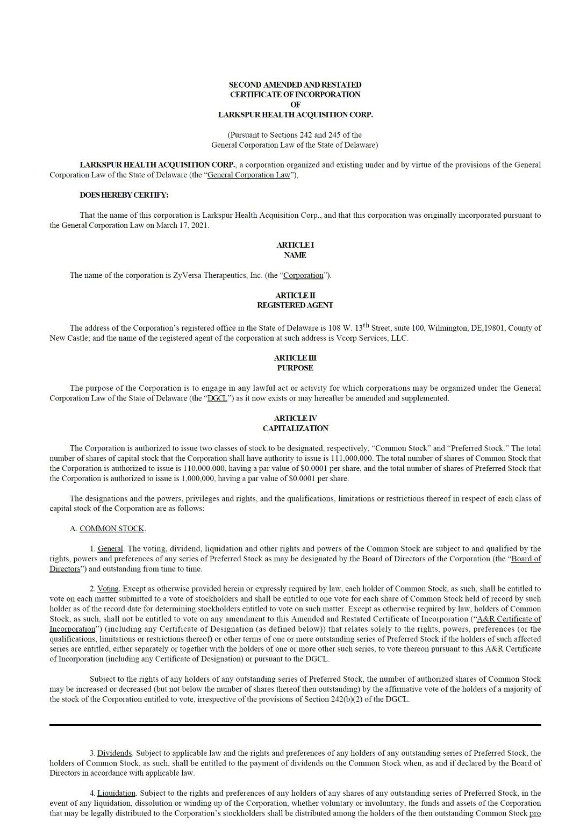

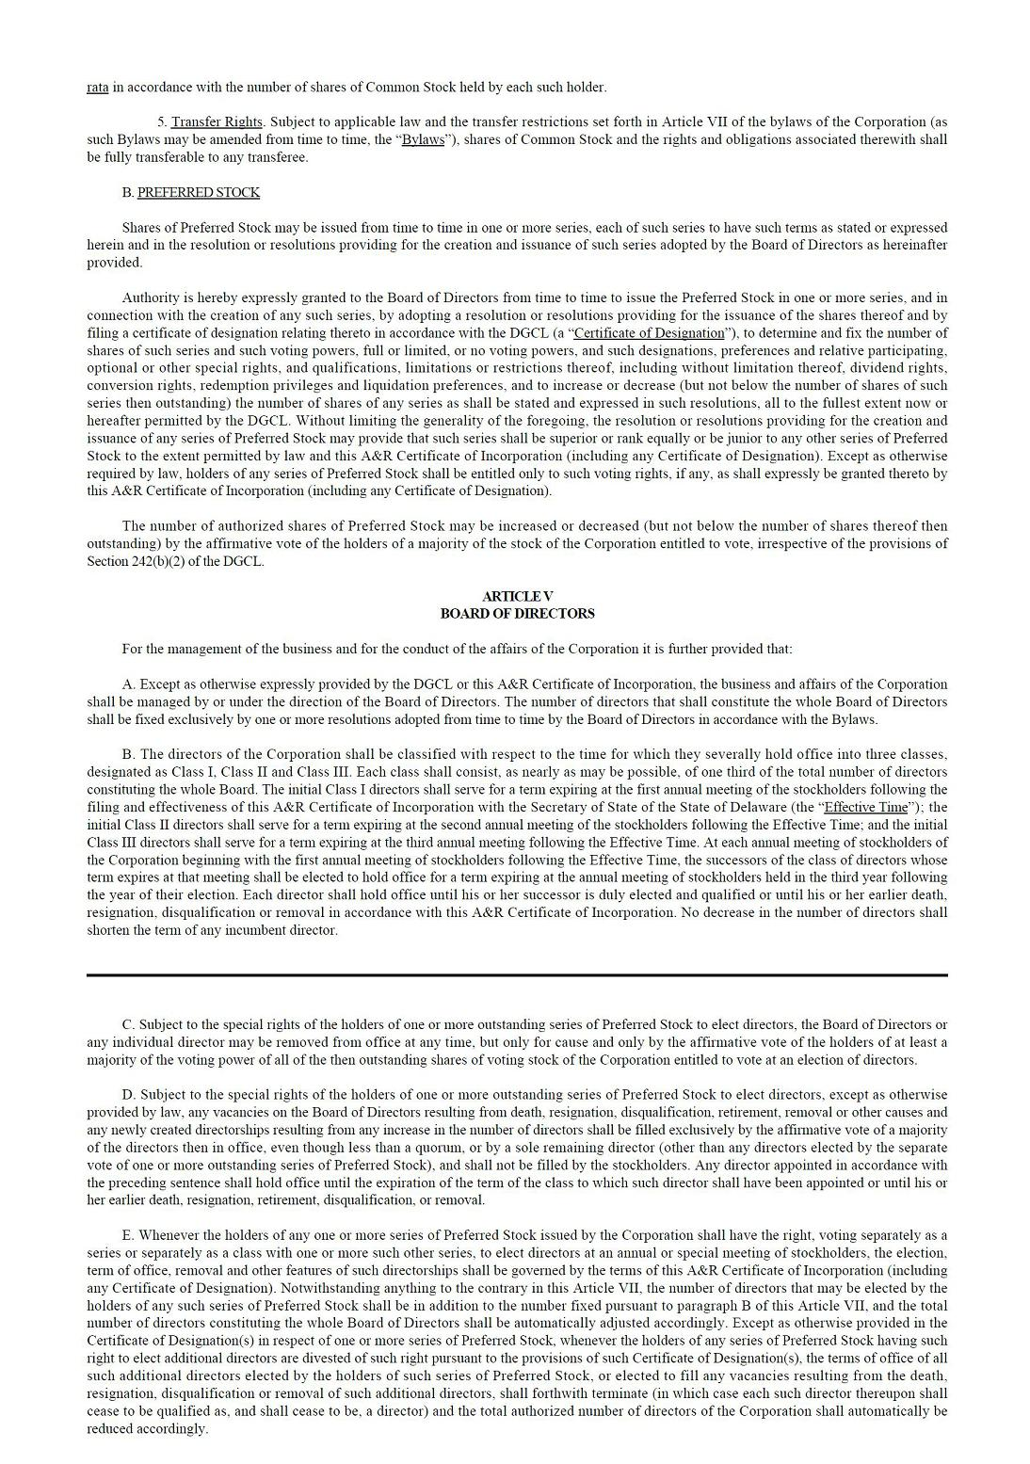

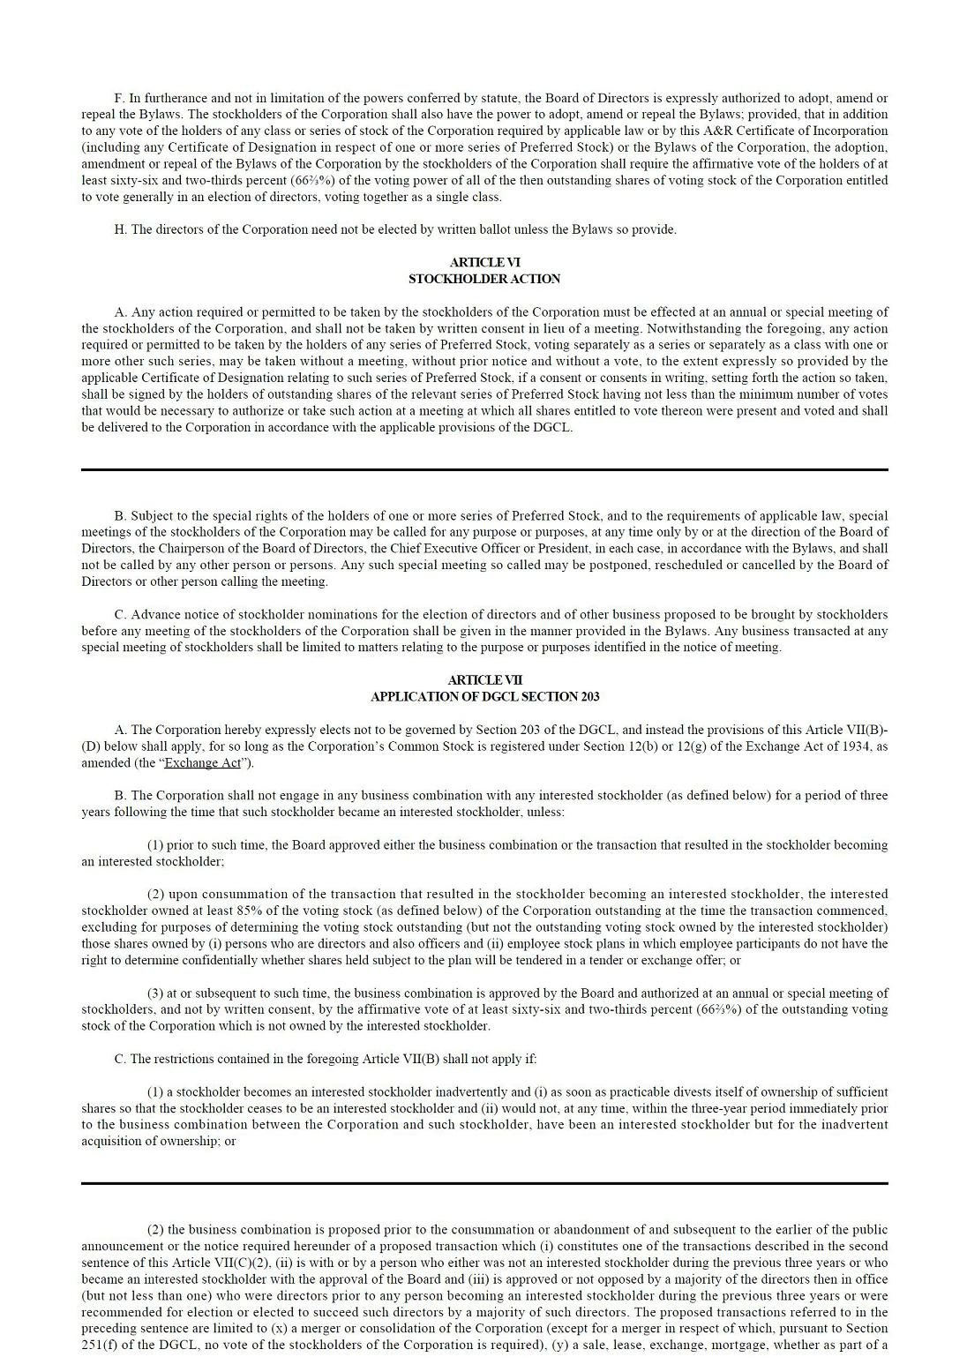

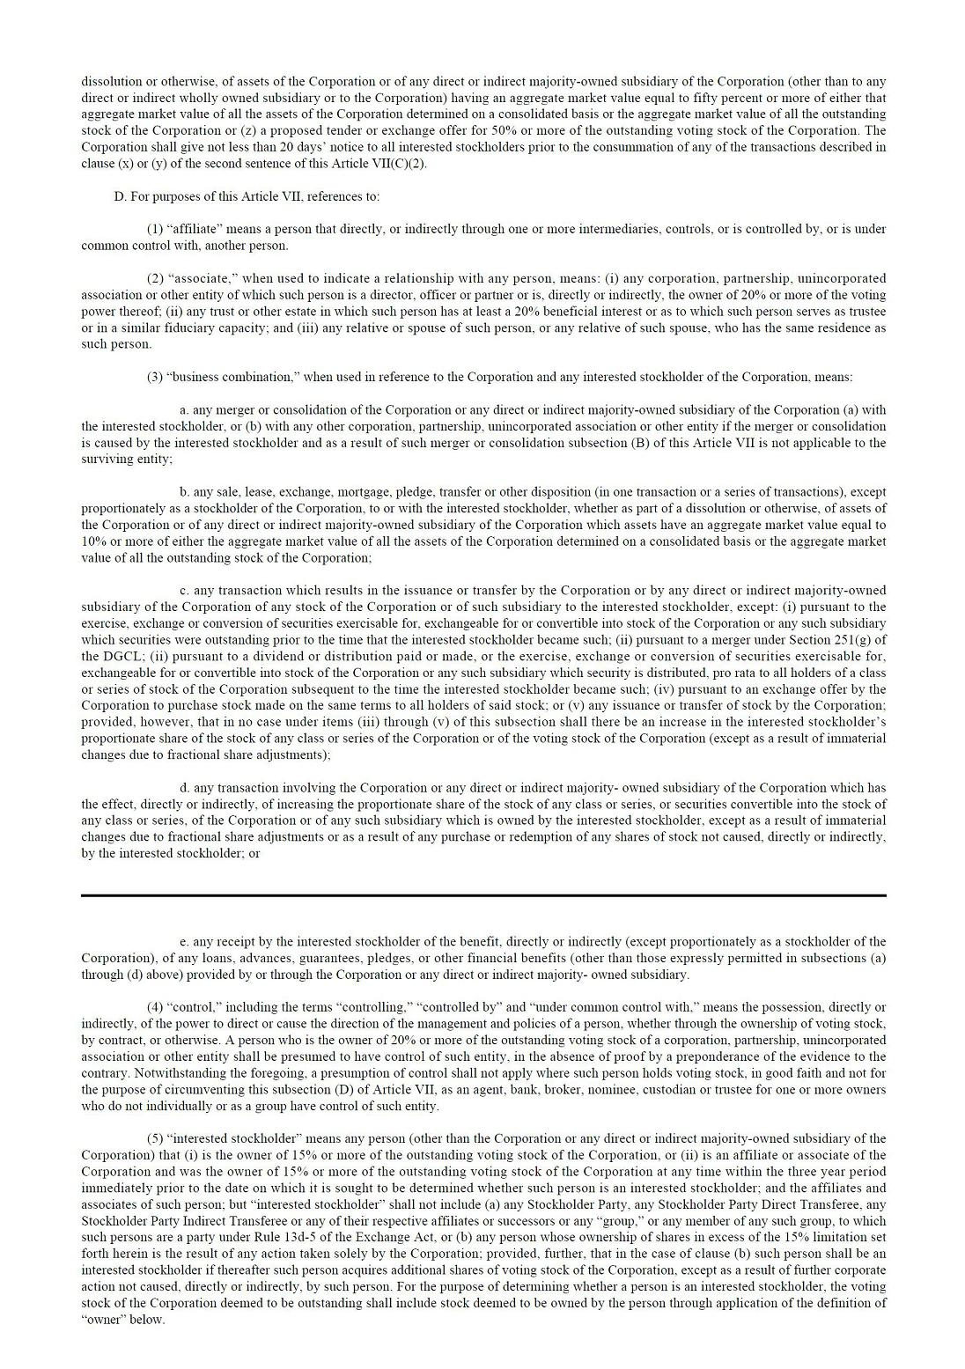

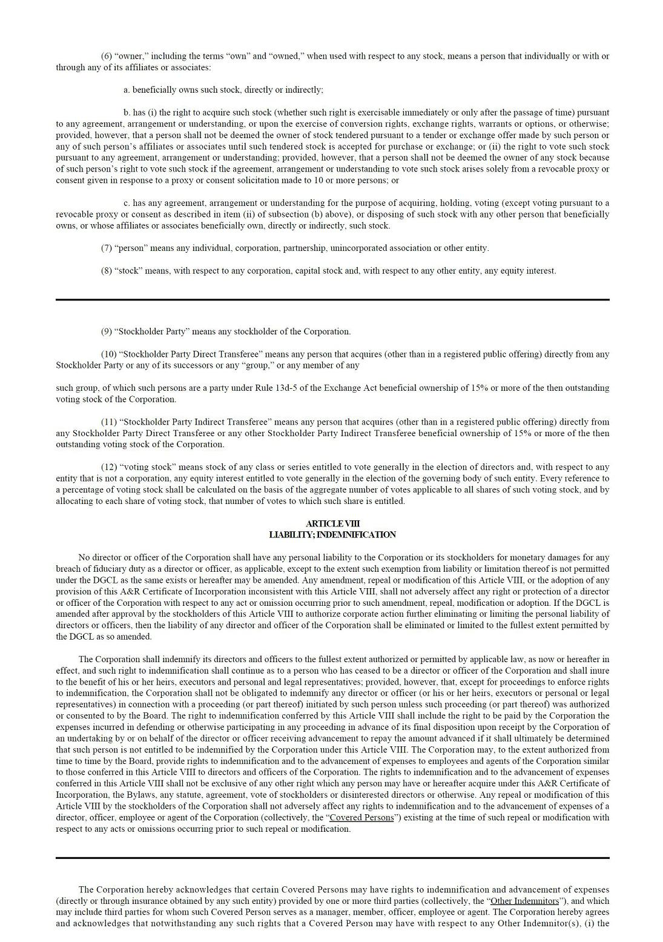

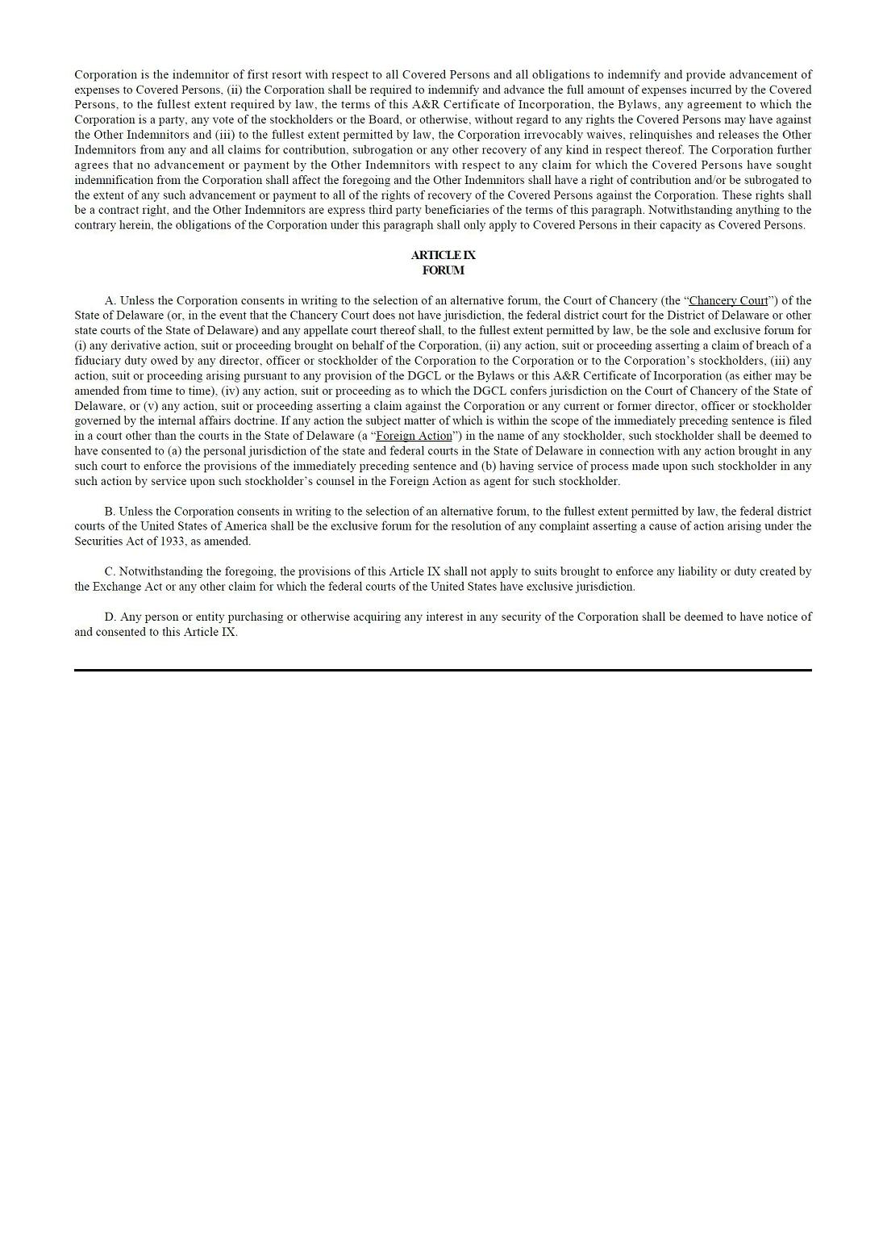

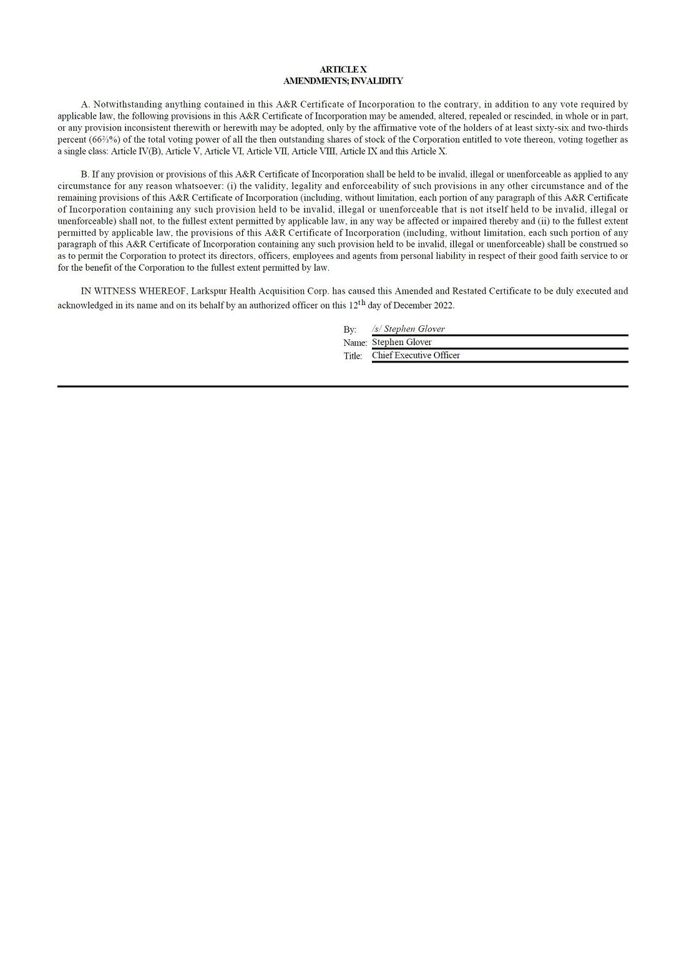

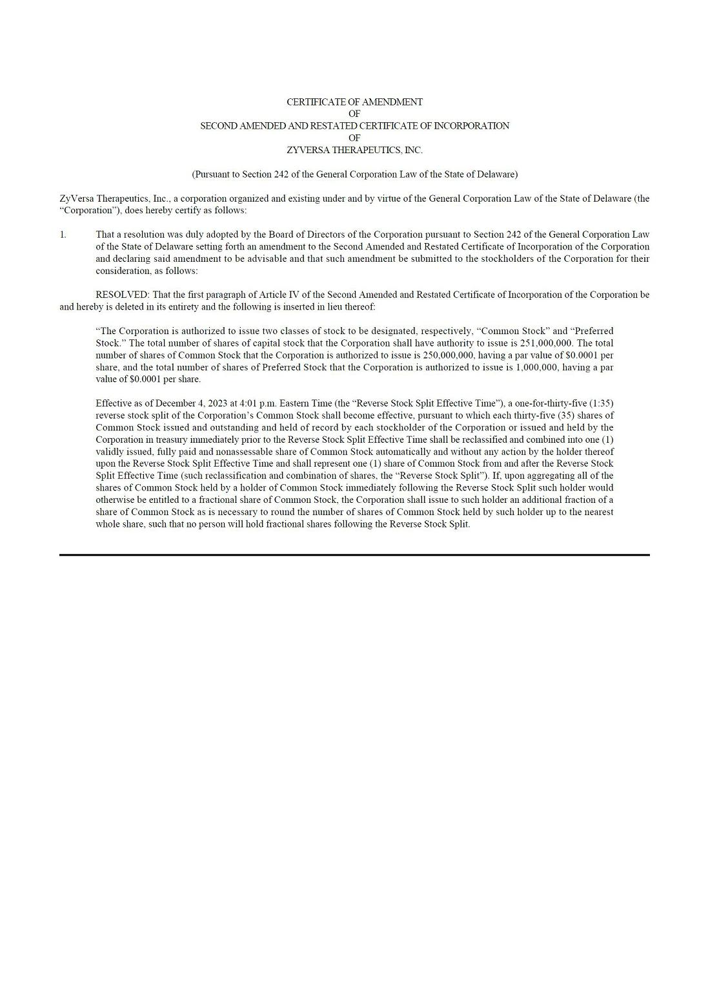

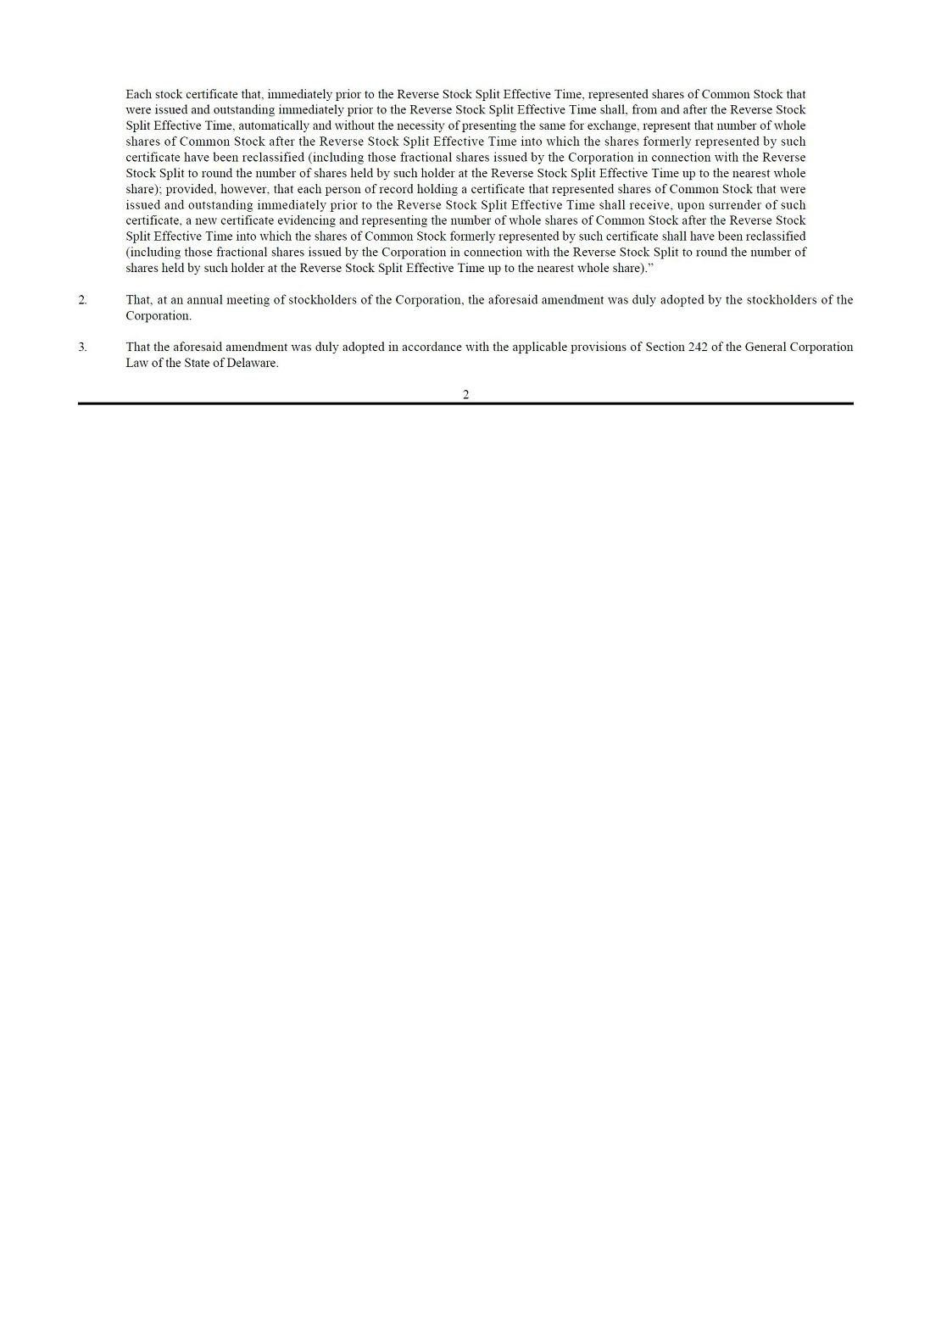



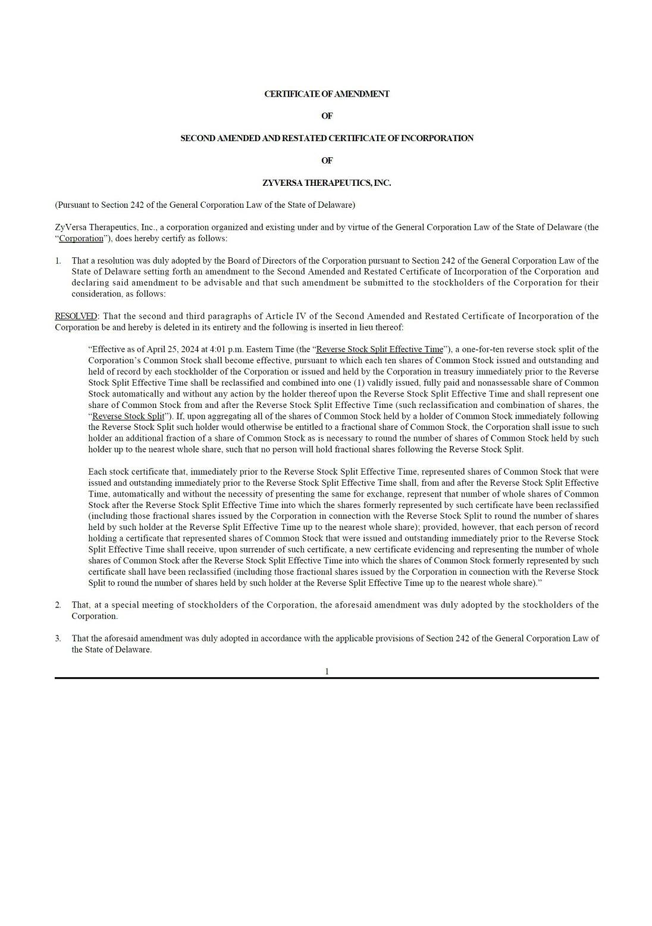

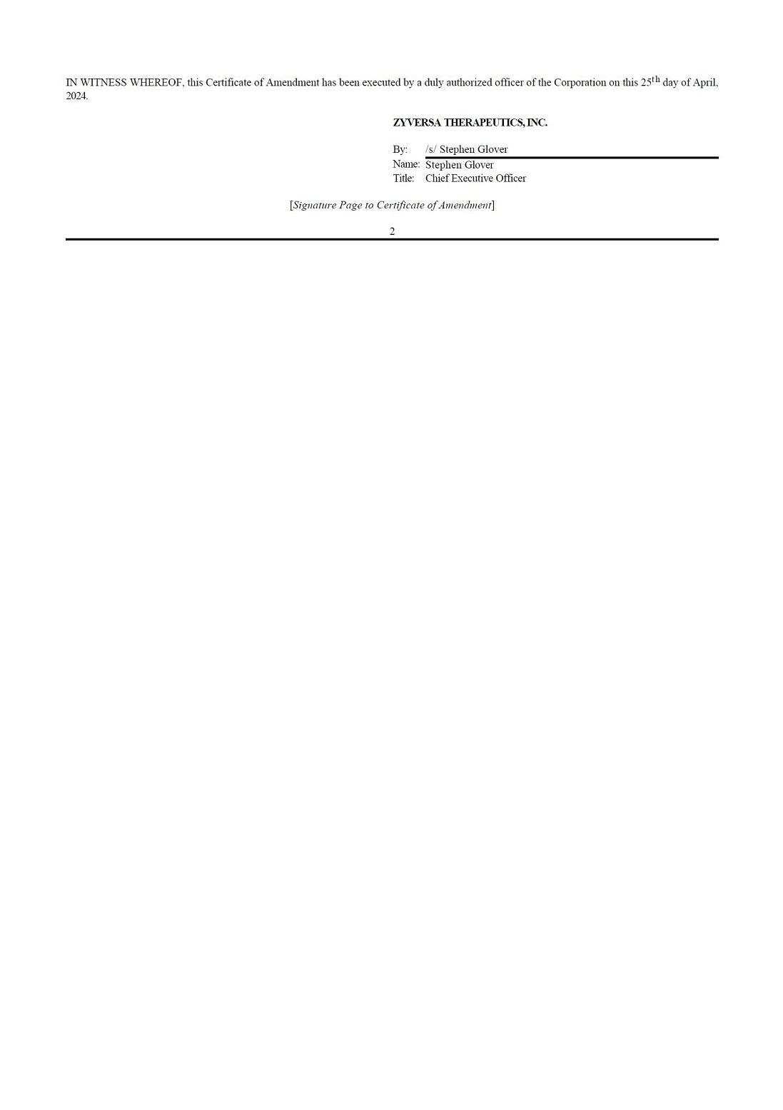

Exhibit 31.1

Certification of

Principal Executive Officer

of ZyVersa Therapeutics, Inc.

Pursuant to Section 302 of the Sarbanes-Oxley Act of 2002

I, Stephen C. Glover, certify that:

- I have reviewed this quarterly report on Form 10-Q of ZyVersa Therapeutics, Inc.;

- Based on my knowledge, this report does not contain any untrue statement of a material fact or omit to state a material fact necessary to make the statements made, in light of the circumstances under which such statements were made, not misleading with respect to the period covered by this report;

- Based on my knowledge, the financial statements, and other financial information included in this annual report, fairly present in all material respects the financial condition, results of operations and cash flows of the registrant as of, and for, the periods presented in this report;

- The registrant’s other certifying officer(s) and I are responsible for establishing and maintaining disclosure controls and procedures (as defined in Exchange Act Rules 13a-15(e) and 15d-15(e)) and internal control over financial reporting (as defined in Exchange Act Rules 13a-15(f) and 15d-15(f) for the registrant and we have:

  - Designed such disclosure controls and procedures, or caused such disclosure controls and procedures to be designed under our supervision, to ensure that material information relating to the registrant, including its consolidated subsidiaries, is made known to us by others within those entities, particularly during the period in which this report is being prepared;

  - Designed such internal control over financial reporting, or caused such internal control over financial reporting to be designed under our supervision, to provide reasonable assurance regarding the reliability of financial reporting and the preparation of financial statements for external purposes in accordance with generally accepted accounting principles;

  - Evaluated the effectiveness of the registrant’s disclosure controls and procedures and presented in this annual report our conclusions about the effectiveness of the disclosure controls and procedures, as of the end of the period covered by this report based on such evaluation; and

  - Disclosed in this annual report any change in the registrant’s internal control over financial reporting that occurred during the registrant’s most recent fiscal quarter (the registrant’s fourth quarter in the case of an annual report) that has materially affected, or is likely to materially affect, the registrant’s internal control over financial reporting; and

- The registrant’s other certifying officer(s) and I have disclosed, based on our most recent evaluation of internal control over financial reporting, to the registrant’s auditors and the audit committee of the registrant’s board of directors (or persons performing the equivalent function):

  - All significant deficiencies and material weaknesses in the design or operation of internal control over financial reporting which are reasonably likely to adversely affect the registrant’s ability to record, process, summarize and report financial information; and

  - Any fraud, whether or not material, that involves management or other employees who have a significant role in the registrant’s internal control over financial reporting.

Dated: August 9, 2024 By: /s/ Stephen C. Glover

Stephen C. Glover

Chief Executive Officer

(Principal Executive Officer)

Exhibit 31.2

Certification of

Principal Executive Officer

of ZyVersa Therapeutics, Inc.

Pursuant to Section 302 of the Sarbanes-Oxley Act of 2002

I, Peter Wolfe, certify that:

- I have reviewed this quarterly report on Form 10-Q of ZyVersa Therapeutics, Inc.;

- Based on my knowledge, this report does not contain any untrue statement of a material fact or omit to state a material fact necessary to make the statements made, in light of the circumstances under which such statements were made, not misleading with respect to the period covered by this report;

- Based on my knowledge, the financial statements, and other financial information included in this annual report, fairly present in all material respects the financial condition, results of operations and cash flows of the registrant as of, and for, the periods presented in this report;

- The registrant’s other certifying officer(s) and I are responsible for establishing and maintaining disclosure controls and procedures (as defined in Exchange Act Rules 13a-15(e) and 15d-15(e)) and internal control over financial reporting (as defined in Exchange Act Rules 13a-15(f) and 15d-15(f) for the registrant and we have:

  - Designed such disclosure controls and procedures, or caused such disclosure controls and procedures to be designed under our supervision, to ensure that material information relating to the registrant, including its consolidated subsidiaries, is made known to us by others within those entities, particularly during the period in which this report is being prepared;

  - Designed such internal control over financial reporting, or caused such internal control over financial reporting to be designed under our supervision, to provide reasonable assurance regarding the reliability of financial reporting and the preparation of financial statements for external purposes in accordance with generally accepted accounting principles;

  - Evaluated the effectiveness of the registrant’s disclosure controls and procedures and presented in this annual report our conclusions about the effectiveness of the disclosure controls and procedures, as of the end of the period covered by this report based on such evaluation; and

  - Disclosed in this annual report any change in the registrant’s internal control over financial reporting that occurred during the registrant’s most recent fiscal quarter (the registrant’s fourth quarter in the case of an annual report) that has materially affected, or is likely to materially affect, the registrant’s internal control over financial reporting; and

- The registrant’s other certifying officer(s) and I have disclosed, based on our most recent evaluation of internal control over financial reporting, to the registrant’s auditors and the audit committee of the registrant’s board of directors (or persons performing the equivalent function):

  - All significant deficiencies and material weaknesses in the design or operation of internal control over financial reporting which are reasonably likely to adversely affect the registrant’s ability to record, process, summarize and report financial information; and

  - Any fraud, whether or not material, that involves management or other employees who have a significant role in the registrant’s internal control over financial reporting.

Dated: August 9, 2024 By: /s/ Peter Wolfe

Peter Wolfe

Chief Financial Officer

(Principal Financial and Accounting Officer)

Exhibit 32.1

CERTIFICATION PURSUANT TO 18 U.S.C. SECTION 1350,

AS ADOPTED PURSUANT TO

SECTION 906 OF THE SARBANES-OXLEY ACT OF 2002

In connection with the Quarterly Report of ZyVersa Therapeutics, Inc. (the “Company”) on Form 10-Q for the quarter ended June 30, 2024, as filed with the Securities and Exchange Commission on the date hereof (the “Report”), each of the undersigned officers of the Company certifies, pursuant to 18 U.S.C. Section 1350, as adopted pursuant to Section 906 of the Sarbanes-Oxley Act of 2002, that, to such officer’s knowledge:

- The Report fully complies with the requirements of Section 13(a) or 15(d) of the Securities Exchange Act of 1934, as amended; and

- The information contained in the Report fairly presents, in all material respects, the financial condition and results of operations of the Company as of the dates and for the periods expressed in the Report.

Dated: August 9, 2024 By: /s/ Stephen C. Glover

Stephen C. Glover

Chief Executive Officer

(Principal Executive Officer)

Dated: August 9, 2024 By: /s/ Peter Wolfe

Peter Wolfe

Chief Financial Officer

(Principal Financial and Accounting Officer)

